 | Dissertation Title: | Developing an AI powered Data Protection Officer
 | Surname: | Siwakoti
 | First Name: | Khusi
 | Student Number: | 19387308
 | Supervisor: | Dr. Manny Niri
 | Dissertation Module: | COMP7039: Dissertation in Computing Subjects
 | Course Title: | MSc Computer Science for Cybersecurity
 | Date Submitted: | 25th September, 2026
 | Word Count | 10,030
MASTER OF SCIENCE DISSERTATION
FINAL REPORT
Statement of Originality

Except for those parts in which it is explicitly stated to the contrary, this project is my own work. It has not been submitted for any degree at this or any other academic or professional institution.

Signature of Author | Khusi Siwakoti | Date | 25th September 2026

Regulations Governing the Deposit and Use of Master of Science Dissertations in the School of Engineering, Computing and Mathematics, Oxford Brookes
University.

- A copy of dissertation final reports submitted in fulfilment of Master of Science course requirements shall normally be kept by the school.

- The author shall sign a declaration agreeing that, at the supervisor’s discretion, the dissertation will be submitted in electronic form to any plagiarism checking service or tool.

- The author shall sign a declaration agreeing that the dissertation be available for reading and copying in any form at the discretion of either the dissertation supervisor or in their absence the Programme Lead of Postgraduate Programmes, in accordance with 5 below.

- The project supervisor shall safeguard the interests of the author by requiring persons who consult the dissertation to sign a declaration acknowledging the author's copyright.

- Permission for anyone other than the author to reproduce in any form or photocopy any part of the dissertation must be obtained from the project supervisor, or in their absence the Programme Lead of Postgraduate Programmes, who will give his/her permission for such reproduction only to the extent to which he/she considers to be fair and reasonable.

I agree that this dissertation may be submitted in electronic form to any plagiarism checking service or tool at the discretion of my project supervisor in accordance with regulation 2 above.

I agree that this dissertation may be available for reading and photocopying at the discretion of my project supervisor or the Programme Lead of Postgraduate Programmes in accordance with regulation 5 above.

Signature of Author | Khusi Siwakoti | Date | 25th September 2026

Table of Contents
1 Introduction 1
1.1 Background 1
1.2 Aim 3
1.3 Objectives 3
1.4 Product Overview 4
2 Literature Review 6
2.1 The Ongoing Threat to Web Applications 6
2.2 GDPR and the Pressure on the DPO 7
2.3 Existing Tools and the Accessibility Problem 7
2.4 Similar Tools and Academic Approaches 8
2.5 Artificial Intelligence integration in this project 9
2.6 Research Gap and Contribution 10
3 Methodology 12
3.1 Research and Development Approach 12
3.1.1 Design Science Research 12
3.1.2 Agile Development 12
3.2 System Requirements 13
3.2.1 Functional Requirements 14
3.2.2 Non Functional Requirements 15
3.3 Changes from the Original Proposal 16
3.4 System Design 17
3.4.1 System Architecture 17
3.4.2 Frontend Design 17
3.4.3 Backend Design 18
3.4.4 Database Design 18
3.5 Technology Stack 19
3.6 Version management 21
4 Results 22
4.1 User workflow 22
4.2 System Implementation 23
4.2.1 Landing Page and Authentication 23
4.2.2 Dashboard 24
4.2.3 DPO hub 26
4.2.4 Requirements Traceability 27
4.2.5 Task 1 – Map your Data 28
4.2.6 Task 2 – Check Your Practices 30
4.2.7 Task 3 – Assess Risks 32
4.2.8 Task 4 – Handle Requests 33
4.2.9 Task 5 – Monitor threats 35
4.2.10 Task 6 – Manage policies 37
4.2.11 Task 7 – Train your team 38
4.2.12 AI cross task intelligence 40
4.2.13 Detection Engine 41
4.3 Testing and Evaluation 42
4.3.1 Detection Engine Testing 42
4.3.2 AI Response Evaluation 43
4.3.3 Limitations 44
4.4 Project Management 44
4.5 Risk Analysis 46
4.6 Professional Issues 47
4.6.1 Legal issues 47
4.6.2 Ethical issues 47
4.6.3 Social Issues 48
4.6.4 Environmental Issues 48
4.6.5 Sustainability 48
5 Conclusion 49
5.1 Summary of Achievements 49
5.2 Future Work 50
5.3 Personal Reflection 50

Table of Figures
Figure 1: System architecture diagram 17
Figure 2: Database design of the system 19
Figure 3: GitHub repository page 21
Figure 4: User workflow diagram 22
Figure 5: landing page 23
Figure 6: Registration page 24
Figure 7: Dashboard for new user 25
Figure 8: Stakeholder impact section 25
Figure 9: Dashboard at 100% showing confetti and downloadable certificate 26
Figure 10: DPO hub page 27
Figure 11: Auto generate dropdown option 28
Figure 12: Inventory table with generated data 29
Figure 13: Bulk deletion of data plus ai analyse button 29
Figure 14: AI analysis 30
Figure 15: Compliance questions for task 2 31
Figure 16: Score and AI assessment 31
Figure 17: guided selectors for task 3 32
Figure 18: Live score meter or risk meter 32
Figure 19: AI risk assessment result 33
Figure 20: Requests with countdown bars 34
Figure 21: AI draft response letter 34
Figure 22: Test box with SQL injection typed 35
Figure 23: Threat logged and auto classified 35
Figure 24: Incident page lists 36
Figure 25: PDF breach report, with all the incident details 36
Figure 26: Policy generation using ai or manual creation 37
Figure 27: Generated policy with AI review 38
Figure 28: Flip cards for different modules 38
Figure 29: Quiz questions 39
Figure 30: Quiz results and progress bar 40
Figure 31: AI cross task insights results 41
Figure 32: Search page detecting attack 41
Figure 33: Brute force detection 42
Table of Tables

Table 1: Functional requirements in the system 15
Table 2: Nonfunctional requirements of the system 16
Table 3: Requirements traceability table 24
Table 4: Detection engine test results 29
Table 5: Sprint breakdown showing development progress 31
Table 6: Risk analysis with likelihood, impact and mitigation strategies 33

List of Abbreviations

Abbreviation | Full Form
AI | Artificial Intelligence
BCS | The chartered Institute for IT (formerly British Computer Society)
DPO | Data Protection Officer
CRUD | Create, Read, Update, Delete
GDPR | General Data Protection Regulation
HTML | Hypertext Markup Language
IDS | Intrusion Detection System
API | Application Programming Interface
DPIA | Data Protection Impact Assessment
OWASP | Open Web Application Security Project
PDF | Portable Document Format
SIEM | Security Information and Event Management
SME | Small and Medium sized Enterprise
SQL | Structured Query Language
SQLite | Lightweight Embedded SQL Database Engine
URL | Uniform Resource Locator
XSS | Cross site scripting
UI | User Interface
SAR | Subject Access Request
ROPA | Record of Processing Activities
ICO | Information Commissioner's Office
CSS | Cascading Style Sheets

Abstract
This report presents the design and development of an AI powered Data Protection Officer (DPO) system. A web based application that enables users to perform the core responsibilities of a DPO through a guided, interactive environment. The system addresses a documented gap in the market: small and medium sized organisations that are legally required to comply with GDPR but lack the resources for enterprise security tools or dedicated data protection personnel. By using Python, Flask, SQLite and the Anthropic Claude API, the system provides seven structured tasks covering data mapping, compliance assessment, risk evaluation, data request handling, real time threat monitoring, policy management and staff training. A rule based detection engine scans user inputs across the application for five types of web application attacks, with AI providing automatic incident classification and severity assessment. The system generates GDPR compliance breach reports in PDF format and includes cross task AI intelligence that analyses data from all completed tasks to identify risks not visible when tasks are considered individually. Testing through simulated attack scenarios demonstrated effective detection of common web application threats, while AI classification provided contextual, actionable recommendations. The project contributes a practical demonstration of how artificial intelligence can be integrated into data protection workflows to make regulatory compliance more accessible for organisations with limited cybersecurity resources.

Acknowledgement
I would like to express my gratitude to my supervisor Dr. Manny Niri, for his consistent guidance, feedback and support throughout this project. His advice on expanding the system beyond basic breach detection to cover the full scope of DPO responsibilities significantly improved the quality and depth of this project.

I would also like to thank Oxford Brookes University and the School of Engineering, Computing and Mathematics for providing the resources and academic framework that made this dissertation possible.

Finally, I would like to thank my family and friends for their encouragement and patience throughout the course of this project.

Introduction

Background
The volume of personal data processed by web applications has grown substantially over the past decade. Organisations of all sizes now rely on online platforms for customer transactions, internal communications and data storage, making web applications an increasingly attractive target for cyber attackers. Common threats such as phishing, brute force login attempts, SQL injection and cross site scripting continue to cause significant damage, largely because many web applications still contain fundamental security weaknesses that remain unaddressed (OWASP , 2021).

The financial and reputational consequences of data breaches are well documented. The IBM cost of a Data Breach Report (IBM, 2024) found that the average cost of a breach reached $4.45 million globally, with organisations taking an average of 277 days to identify and contain an incident. The Verizon Data Breach Investigations Report (Verizon, 2023) identified phishing and stolen credentials as the two most common initial attack vectors, accounting for over 60% of breaches analysed. These findings suggest that monitoring login behaviour, scanning user inputs and detecting suspicious URLs should be fundamental priorities for any detection system.
The introduction of the European Union’s General Data Protection Regulation (GDPR) in 2018 transformed breach detection and reporting from good practice into a legal obligation. Article 33 requires organisations to notify their supervisory authority within 72 hours of becoming aware of a qualifying personal data breach (European Parliament, 2016). Articles 37 to 39 further require certain organisations to appoint a Data Protection Officer (DPO) whose responsibilities include monitoring internal compliance, advising on data protection matters, overseeing impact assessments and serving as the contact point with regulatory authorities. In the United Kingdom, the Data Protection Act 2018 implements equivalent requirements under the UK GDPR framework.
The practical challenge is that fulfilling these obligations requires both technical capability and specialist knowledge. Enterprise grade tools such as Splunk, IBM QRadar and commercial Security Information and Event Management (SIEM) platforms can address monitoring and compliance requirements, but they carry substantial licensing costs and require dedicated security personnel to operate (Bhatt, et al., 2014). The European Union Agency (ENISA, 2021) found that small and medium sized enterprises across Europe frequently lack both the cyber security personnel and the budget for such solutions. This creates a significant gap: organisations that are legally required to detect breaches and maintain compliance often do not have access to the tools or expertise needed to do so effectively.

This project addresses that gap by developing an AI Powered Data Protection officer, a web-based application that enables users to perform the core responsibilities of a DPO through a guided, interactive system. Rather than simply detecting threats and generating reports, the system takes a broader approach. It guides users through seven structured tasks that mirror the real-world responsibilities of a Data Protection Officer, with artificial intelligence providing analysis, classification and recommendations at each stage. The system combines rule-based threat detection with AI powered incident classification, automated compliance assessment and GDPR compliant report generation. It helps to make data protection accessible to organisations that lack specialist resources.

Aim
To design and develop an AI powered data protection officer system that enables users to perform the core responsibilities of a DPO through an interactive web application. It incorporates real time threat detection, AI driven incident classification, automated compliance assessment and GDPR compliant breach report generation.

Objectives
- To investigate the role and responsibilities of DPO in any organisation and to analyse how these obligations translate into functional system requirements.
- To critically review existing monitoring and compliance tools, identifying their limitations for smaller organisations and establishing research gap this project addresses.
- To design and implement a web application monitoring framework that detects common web application threats.
- To build a structured task-based system covering core DPO responsibilities.
- To implement automated GDPR compliant breach report generation and data inventory reporting in PDF format.
- To implement automated GDPR compliant breach report generation and data inventory reporting.
- To develop an AI powered incident classification module that automatically assesses the severity of detected threats and determine whether they are reportable under GDPR law.

Product Overview
The AI powered Data Protection Officer is a Flask based web application that provides users with a complete, guided environment for performing the role of a DPO. The system is structured around seven interactive tasks, each corresponding to a core DPO responsibility as defined by GDPR Articles and established data protection practice. These tasks are:
- Map your Data: Users build a comprehensive inventory of the personal data their organisation holds, including purpose of collecting, legal basis, access controls, retention periods and security measures. The system can auto generate a starter inventory based on organisation type and provide an AI analysis of data for risks and gaps.
- Check your Practices: A structured compliance assessment where user answers eight questions about their data handling practices. The system calculates a compliance score, and AI provides specific recommendations for improvement.
- Assess Risks: An interactive risk assessment tool where users select project type, data categories, scale and sharing arrangements through guided selectors. The system calculates a preliminary risk score in real time, then the AI provides a detailed impact assessment with specific safeguards.
- Handle Requests: A request tracking system with an automatic 30-day countdown timer reflecting GDPR deadline for responding to data subject requests. The AI can generate realistic, simulated requests for practice and draft professional response letters.
- Monitor threats: A real time threat detection engine that scans all user inputs across application for five types of web application attacks. Detected incidents are automatically classified by the AI and downloadable and the breach reports are generated.
- Manage Policies: A policy management tool where users can generate data protection policies from templates using AI or write their own. The AI revies existing policies and provides an assessment of their adequacy with specific improvement suggestions.
- Train your team: An AI generated training module with interactive flip cards and multiple-choice quizzes. Users must pass three different training topics to complete tasks, reflecting the DPO’s responsibility to ensure staff awareness across multiple areas.

The system also includes a dashboard with compliance tracking, a stakeholder impact section showing how the DPO’s work affects different groups (management, staffs, data subjects and regulators). Also, there is an AI cross task intelligence feature that analyses data from all completed tasks together to identify risks that are only visible when multiple areas are considered simultaneously. Upon completing all tasks, user receives a downloadable DPO completion certificate.

The technology stack consists of Python 3.12, Flask as web framework, SQLite for data storage, bootstrap 5 for the front-end interface, Anthropic Claude API for AI powered analysis and classification and Report Lab for PDF report generation. Version control is managed through Git with a GitHub repository. The system is designed as an academic prototype that demonstrates how AI can be integrated into data protection workflows to make compliance accessible for organisations with limited resources.

Literature Review
This part of the report looks at the research and tools that relate to my system. Instead of just describing each source one by one, I try to compare them and show how they connect. The review is split into five parts; the threats web application face, what GDPR requires from organisations, the tools that already exist, similar academic tools that use AI and how large language models are being used in this area. Putting these together shows the gap that my project fills.

The Ongoing Threat to Web Applications
Most researchers agree on one thing, web applications are a major target for attackers, and the worst attacks are also the ones we understand best. The (OWASP , 2021) puts injection attacks like SQL Injection at the top of its list and this is the third time in a row it has done so. That is telling. It means that even after years of warnings, organisations still fail to fix basic weaknesses. (Edgescan, 2023) backs this up with numbers. They found SQL injection makes up 23.4% of web vulnerabilities and cross site scripting makes up 19.1%. So OWASAP gives us the ranking and Edgescan gives us the proof.

(DIsawal & Suman, 2023) explain how SQL injection and XSS actually work and how to stop them. Their paper is helpful because it shows why these attacks do not go away. They happen when user input is not checked properly before the system uses it. This is easy to explain but hard to fix in real projects. Their focus is quite narrow though. They look at the code level, not what the organisations should do about it. (Verizon, 2023) takes a wider view. They report that phishing and stolen passwords are involved in more than 60% of breaches. This moves the focus away from just technical bugs and towards people, which is something I come back to later when talking about staff training.

Together, these sources tell me which threats my system needs to catch. The five attack types I focus on, SQL injection, XSS, path traversal, phishing and brute force are exactly the ones these papers say are most common and most damaging. So, the literature directly supports what my detection engine targets.

GDPR and the Pressure on the DPO
If the first part is about the threat, the second is about the legal duty to deal with it. GDPR (European Parliament, 2016) is the main law here. It sets out the rules that shape my whole project. Article 30 says you must keep a record of your data. Article 33 says you must report breaches within 72 hours. Article 35 says you must assess risks. And Article 37 to 39 say some organisations must appoint a DPO. The problem is that the law says what to do, not how to do it. That is where other sources help.

(Tankard, 2016) explains what GDPR means for a business in real terms. He wrote this just before GDPR came into effect and predicted that many organisations would find it hard to follow. The (EDPB, 2024) report, written eight years later, shows he was right. They surveyed over 17000 organisations across 25 countries. They found that DPOs often do not have enough resources get given other jobs at the same time and that many companies just tick boxes instead of really protecting data. The gap between what Tankard predicted and what the EDPB actually found is striking. The problems were obvious years ago, but they are still not fixed. This is a big reason why I wanted to build a tool that actively helps existing DPO, itself performing DPO role not just one that records things.

Existing Tools and the Accessibility Problem
So, if the threats and the legal duties are clear, do existing tools already solve this? This literature review says they solve parts of it but not for the organisations that need help the most. (Bhatt, et al., 2014) look at SIEM systems, which are industry standard for monitoring. They are honest about the problems. SIEM systems create huge numbers of alerts, need skilled analysts to read them and have to be constantly adjusted. Their study is a bit old now but the core issue they describe is complexity and needing experts which are still true today.

This is where the accessibility problem shoes up. The ENISA report on cybersecurity for SMEs found that many small businesses across Europe lack both the budget and the personnel for dedicated security tools, with 57% saying they would likely go out of business if hit by serious cyber incident (ENISA, 2021). Open-source alternatives do exist. Snort and Suricata are widely used network-based intrusion detection systems that can identify suspicious traffic patterns. OSSEC provides host-based monitoring with log analysis and file integrity checking. The ELK Stack, which combines Elasticsearch, Logstash and Kibana is commonly used for centralised log management and basic security analytics. However, all of these tools require significant technical knowledge to install, configure and maintain. They are not designed for someone without a security background to pick up and use straight away.

What actually is missing from the current scenario is a tool that brings together security monitoring and DPO compliance support in one place, at a level that is accessible to someone without specialist training. Enterprise SIEMs handle monitoring but not threat detection. This project attempts to bridge the gap by combining both functions in a single, AI assisted web application.

Similar Tools and Academic Approaches
Some researchers have already tried using automation and AI to help with GDPR compliance, so it is important to look at their work and see where my project fits. The thing is most of these tools only focus on one small part of compliance not the full DPO role. A lot of work in this area from (Amaral Cejas, et al., 2023) at the University of Luxembourg. Their tool uses natural language processing to check whether Data Processing Agreement follows GDPR. It is a clever and well tested system but it only looks at one type of legal document. It does not detect attacks, handle data requests or train staff. The same team also built a tool that checks how complete a privacy policy is against GDPR. Again, useful but it only deals with policy text and nothing else.

More recently, (Mittal, et al., 2024) built something they call a way to democratise GDPR compliance. They use large language models to read privacy policies and explain them to normal users in simple language. This one is closer to my project because it also cares about making things accessible and uses LLMs to explain not just classify. But it still only handles privacy policies, not the wider set of jobs a DPO does.
When I look at all these tools, one pattern stands out. Each one does a single compliance task really well, checking an agreement, reading a policy or helping with one decision. There is a clear move towards using NLP and now LLMs to make compliance easier. But none of them combine security monitoring with compliance and none try to cover full DPO role in one system. This actually confirms two things for me: AI is the right technology for this and there is a real gap for a tool that does everything together. My project builds on the direction these researchers started but takes LLMs from single task checking all the way to the full DPO role.

Artificial Intelligence integration in this project
The use of AI in this project is not about building a general cybersecurity tool. It is specifically about supporting DPO role. A Data Protection Officer needs to do more than just detect threats. They need to understand how serious an incident is, decide whether it needs to be reported, draft responses to people asking about their data, review policies and train staff. These are all tasks that require understanding context and giving something as good or bad.

While traditional machine learning classifiers have shown strong detection accuracy for web attacks (Baklizi, et al., 2024), they can only label an input as malicious or safe. they cannot explain why, recommend what to do next or draft a letter to a data subject. Recent research has shown that large language model offers advantages in cybersecurity context because they can understand context and provide human readable explanations (Chen, et al., 2024). This is why the project uses Anthropic Claude API rather than a traditional machine learning classifier. A trained classifier can label an input as malicious or safe, but it cannot explain why, recommend what to do next or draft a letter to a data subject. A large language model can do all of these things because it understands natural language and can reason about context.

In this system, AI is used in six specific ways. First, it analyses the data inventory and identifies risks and gaps. Second, it assesses compliance answers and gives improvement recommendations. Third, it evaluates new projects for data protection risks. Fourth, it drafts professional response letters for data subject requests. Fifth, it classifies detected security incidents by severity and determines whether they are reportable under GDPR Article 33. Sixth, it generates training content with quiz questions to test staff answers.

There is also a cross task intelligence feature where the AI looks at data from all completed task together. This is important because some risks only become visible when you look at the full picture. For example, having high risks data in the inventory but no matching breach response policy is a problem that you would only spot by looking at Task 1 and 6 together.

The decision to use an API based model rather than training a local classifier was practical. Training a machine learning model requires a large dataset and ongoing maintenance. The Claude API provides access to a model that already understands cybersecurity concepts, GDPR requirement and DPO practices without needing a custom training pipeline. This made it possible to integrate AI across all seven tasks rather than limiting to just one function.

Research Gap and Contribution
The review of existing literature and tools reveals a clear gap. On one side, there are enterprise grade security monitoring tools that are powerful but expensive, complex and designed for organisations with dedicated security teams. On the other, there are compliance platforms that manage administrative side of data protection but do not integrate any security monitoring capability. In between, there are smaller organisations that need both functions but cannot access either.

Additionally, while there is growing research into AI based threat detection, most of this work focuses on detection accuracy as a standalone metric. There is far less research into how AI can be integrated into the broader DPO workflow, helping not just to detect threats but to assess compliance, evaluate risks, manage policies, handle data requests and train staff. The DPO role, as defined by GDPR spans all of these areas, yet no existing tool provides AI assisted support across full range of responsibilities.

This project contributes to the field by developing a system that addresses both gaps. It provides an accessible platform that covers the complete DPO role through seven structured tasks, each supported by intelligent analysis. The system is designed for users without specialist security or legal training, uses plain language throughout and requires no infrastructure beyond a web browser. By combining rule based detection with LLM powered analysis, it demonstrates a practical approach to making data protection compliance achievable for organisations with limited resources.

The original project proposal focused primarily on breach detection and reporting with a planned machine learning classifier for incident classification. Following supervisor feedback during development, the scope was expanded to cover full range of DPO responsibilities through a task based system. The AI approach was also changed from a locally trained scikit-learn model to the Anthropic Claude API, which provided more contextual and explainable assessments suitable for nature of DPO task. These changes are documented in the supervision meeting logs and reflects the iterative nature of the Agile development methodology adopted for this project.

Methodology
This section of the report explains how the project was planned, built and managed. It covers the development approach that was followed, the tools and technologies that were chosen and how the code and progress were tracked throughout the project.

Research and Development Approach

Design Science Research
The overall research approach for this project follows the Design Science Research methodology. This approach was first properly described by (Henver, et al., 2004), and it is commonly used in computing and information systems projects where the goal is to build something practical that solves a real problem. The basic idea is simple, identify a problem, design and build a solution, then test it and evaluate whether it actually works. It is different from traditional research where we might just study a topic and write about it. In design science, the output is an actual working system which is exactly what this project produces.

The reason this approach was chosen is because the project is not just about studying GDPR or cybersecurity in theory. It is about building a real tool that a person could use to perform a role of Data Protection Officer. The system itself is the main contribution, and the evaluation comes from testing whether it detects threats correctly, whether the AI gives useful advice and whether the whole thing actually helps someone understand and carry out DPO responsibilities.

Agile Development
For the actual software development, an Agile approach was used. Agile is a way of building software where instead of planning everything upfront and building it all at once, you work in short cycles called sprint. Each sprint is usually one to two week long, and at the end of each one, we have something working that can be showed and get feedback on (Sommerville, 2016).

This was right choice for this system for a few reasons. First, the project changed quite a bit from what was originally proposed. The initial proposal focused mainly on breach detection and reporting, with a machine learning classifier for incident classification. But after discussing it with my supervisor in early meetings, the scope expanded to cover full DPO role through seven tasks. If another approach like waterfall had been used, this kind of change would have meant going back to the start and redoing the requirements. With Agile, it was straightforward as the next sprint simply included new tasks.

The development was organised into roughly weekly sprints. Each sprint had a clear focus. For example, one sprint was dedicated to building detection engine, another to creating the dashboard and checklist pages, and another integrating the AI classification across all tasks. After each sprint, the working system was reviewed and tested before moving on. This meant that bugs and issues were caught early rather than piling up at the end.

Supervisor meeting was held most on Thursday and Monday via google meet which served as review point. Feedback from these meetings directly influenced what was built next. For instance, after the meeting on 13th august, the supervisor pointed out that the system was still too basic and needed a task based checklist structure. This feedback was implemented in very next sprint. After the meeting on 21st august, stakeholder awareness and AI cross task intelligence were added based on the supervisor suggestion that the system needed to demonstrate master level depth. These interactions are documented in the meeting logs.

System Requirements
Before building the system, the functional and nonfunctional requirements were identified. These were based on the GDPR articles studied in the background review, the DPO role analysis and the supervisor feedback revised during meetings. The requirements guided every development decision and are traced back to the final features in the Results chapter.

Functional Requirements
The table below lists the main things the system needs to do.
ID | Requirement
FR1 | Users can register and login with hashed passwords
FR2 | System detects SQL injection, XSS, path traversal, phishing and brute force attacks
FR3 | Detected threats are automatically classified by AI with severity and GDPR reportability
FR4 | Users can build a data inventory and get AI risk analysis
FR5 | Users can check compliance through 8 guided selectors and AI evaluation
FR6 | Users can perform risk assessment with guided selectors and AI evaluation
FR7 | Users can track data subject requests with 30 day countdown and AI draft responses
FR8 | Users can create and review data protection policies with AI
FR9 | Users can complete training through interactive flip cards and quizzes
FR10 | System generates PDF breach reports in GDPR Article 33 format
FR11 | System generates PDF data inventory reports
FR12 | AI analyses all completed tasks together to find cross task risks
FR13 | Dashboard shows progress, compliance score and stakeholder impact

Table 1: Functional requirements in the system

Non Functional Requirements
The table below lists the quality and technical requirements.
ID | Requirement
NFR1 | Each page loads within 3 seconds
NFR2 | Passwords are hashed before storage using Werkzeug
NFR3 | API key is stored in .env file and excluded from version control
NFR4 | System works on chrome, firefox and edge browsers
NFR5 | All text is written in simple English for non-specialist users
NFR6 | System runs on a single machine without needing external server infrastructure
NFR7 | AI responses are cached in the database to avoid unnecessary API calls
NFR8 | System handles errors without crashing

Table 2: Nonfunctional requirements of the system

These requirements guided the development process. Each functional requirement maps directly to one or more features in the final system. The non functional requirements made sure the system stayed secure, accessible and practical throughout development.

Changes from the Original Proposal
It is worth being upfront about how the project evolved from what was originally proposed because these changes were deliberate and well-reasoned not accidental.

The original proposal described a system focused on breach detection and automated reporting, using a machine learning classifier built with scikit learn to categorise incidents. During development, two things became clear. First, the supervisor consistently pushed for the system to cover broader DPO role not just detection. A real DPO does not just watch for breaches. They also map data, check compliance, assess risks, handle request, manage policies and train staff. Limiting the system to detection would have missed the point of what a DPO actually does. Second, the AI approach changed from a locally trained ML model to the Anthropic Claude API. The reason for this was practical. Training a machine learning classifier requires a large, labelled dataset and the model would only be as good as that dataset. An API based large language model, on the other hand can understand context, explain its reasoning and handle variety of tasks that DPO system needs from analysing a data inventory to reviewing a policy to drafting a response letter. A single classifier could not do all of that.

These changes are consistent with Agile methodology, where adapting to feedback and changing requirements is expected rather than seen as a problem. They are also consistent with Design Science Research, where the artefact is refined through iterative cycles of building and evaluating (Henver, et al., 2004).

System Design

System Architecture
The system follows a standard client server architecture. The user interacts with the application through a web browser. All requests go to the Flask server which handles routing, business logic and communication with three backend services: SQLite for data storage, the Claude API for AI analysis and Reportlab for generating PDF reports. The detection engine sits between user inputs and rest of the system, scanning everything before it is processed. Figure 1 shows the full system architecture.

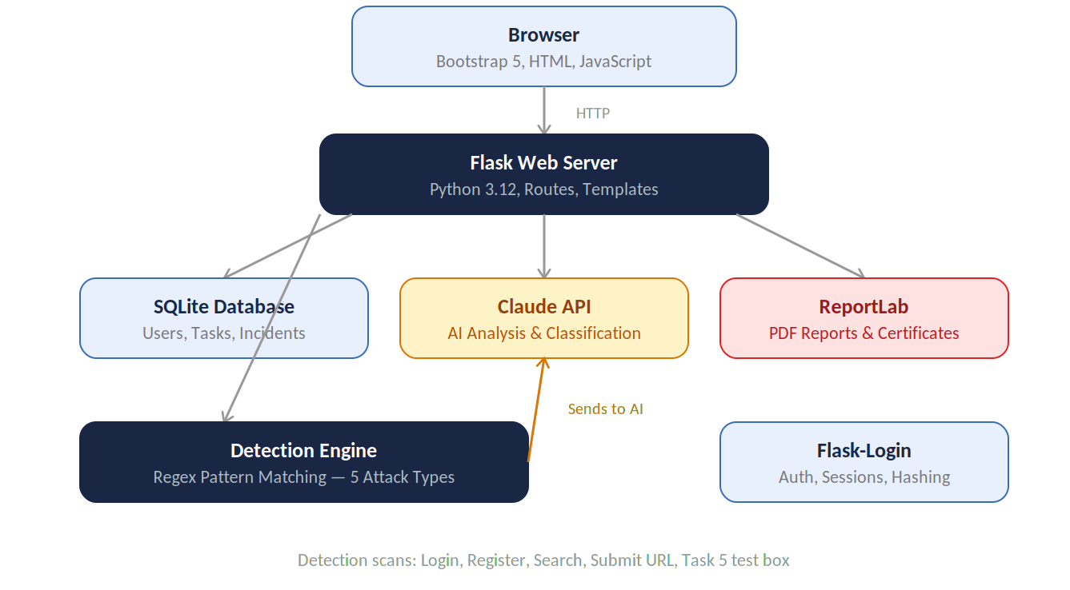

Figure 1: System architecture diagram

Frontend Design
The frontend is built using Bootstrap 5 with custom CSS styling. Every page extends a base template called base.html that contains the navigation bar, footer and common styles. This means changes to the layout only need to be made in one place. Each of the seven tasks has its own template files inside the tasks folder. The monitor pages like incidents, login attempts and activity log are in the monitor folder. Javascript is used for interactive features like the live risk meter in Task 3, the flip cards in Task 7, quiz option selection and the confetti animation on the dashboard. All styling uses a consistent colour scheme with soft card based layouts across the application.

Backend Design
The backend is organised into a single Flask application with all routes defined in rotes.py. The application uses the factory pattern through __init__.py which sets up the database, registers routes and configures login management. Utility functions are separated into three files inside the utils folder. Ai_api.py contains the ask_claude function which handles all communication with the Claude API. Detection.py contains the DetectionEngine class with regex patterns for five attack types. Pdf_report.py contains functions for generating breach reports, data inventory reports and completion certificate. This separation keeps the code organised and makes it easy to update one part without affecting others. Figure 2 shows the project folder structure.

Database Design
The database uses SQLite with Flask SQLAlchemy as the ORM. There are nine main tables. The user table stores account details with hashed passwords. ChecklistProgress tracks which of the seven tsks each user has completed. ROPARecord stores data inventory entries for Task 1. ComplianceRecord stores the eight compliance answers and score for Task 2. DPIARecord stores risk assessment for Task 3. SARRequest stores data subject request for Task 4. Incident stores detected security threats with AI classification results for Task 5. Policy stores generated and reviewed policies for Task 6. TrainingRecord stores training content and quiz scores for Task 7. All tables are ;inked to the user table through a user_id foreign key, meaning each user has their own separate data. Figure 3 shows the database schema.
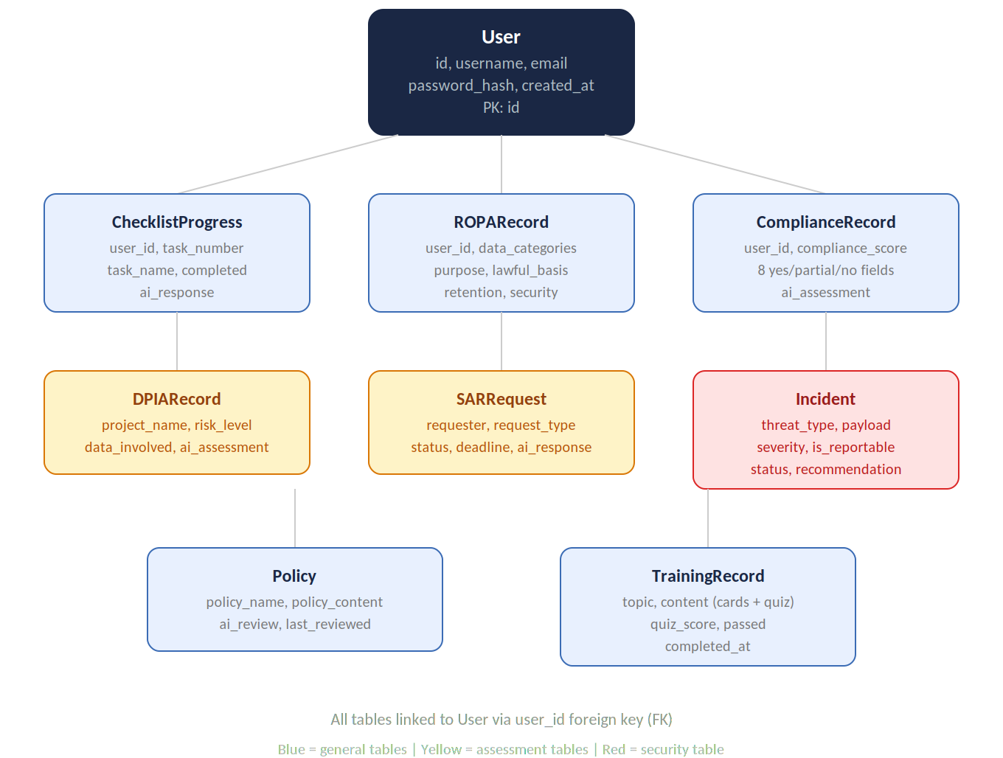

Figure 2: Database design of the system

Technology Stack
The choice of technologies was based on what would be practical, reliable and appropriate for an academic project of this scope. Everything used is either open source or available through a free or low-cost API.

- Python 3.12 was used as the main programming language. Python was a natural choice because it has strong library support for web development., data processing and working with APIs.
- Flask was chosen as the web framework. Flask is a lightweight Python framework that gives you the basic tools fo0r building a web application. It includes routing, templates, sessions without forcing you into a solid structure. This was preferred over a heavier framework like Django because the project did not need features like an admin panel. Flask’s simplicity, made it easier to organise the code and add features incrementally which suited the Agile approach.
- SQLite was used for the database. It is a file-based database that does not require a separate server, which makes it easy to setup and ideal for a prototype. The database stores user accounts, checklist progress, data inventory records, compliance checks, risk assessment, data requests, security incidents, policies and training records. Flask SQL Alchemy was used as the object relational mapper to interact with database using python rather than raw SQL queries.
- Bootstrap 5 was used for the frontend interface. It provides responsive grid layouts, prebuilt components and utility classes that made it possible to build a clean, professional looking interface without spending weeks on CSS. Bootstrap icons were also used throughout the application for visual consistency.
- The Anthropic Claude API was used for all AI powered features. The model used was Claude sonnet 4.6, accessed through the official anthropic python library. The Api key is stored in .env file that is excluded from version control via .gitignore, following standard security practice. The AI is used for six distinct functions across the system: analysing data inventories, assessing compliance, evaluating project risks, drafting responses to data request, classifying security incidents, reviewing policies and generating training content with quizzes.
- ReportLab was used to generate PDF documents. The system produces two types of PDF: Article 33 breach reports that include al; the fields required for notifying the ICO about a data breach and data inventory reports that summarise the organisation's Record of Processing Activities. A DPO completion certificate is also generated as a PDF when all seven tasks are finished.
- Other libraries used included Flask login for managing user authentication and sessions, Werkzeug for password hashing and python dotenv for loading environment variables from the .env file.

Version management
Git was used for version control throughout the project, with the code hosted in a GitHub repository. Every significant piece of work was committed with a descriptive message so that the history of the project can be tracked from start to finish. The repository is available at: https://github.com/khusigit11/AI-powered-DPO .
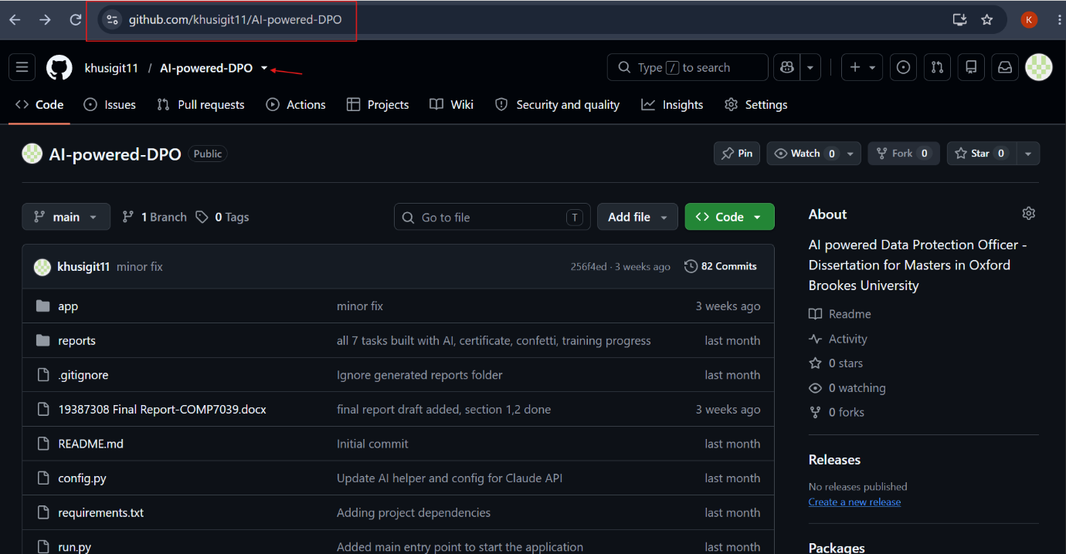
Figure 3: GitHub repository page

The project uses a single main branch. While feature branches could have been used, a single branch was sufficient for a solo developer project where there were no merge conflicts to manage. Commits were made at least daily during active development and often multiples times per day when building individual features.

Sensitive files are excluded from the repo using .gitignore file. This includes the .env file containing API key, SQLite database file and reports folder generated PDFs are stored. This follows a practice for keeping credentials and user data out pf version control.

The supervisor has access to the repository and can view the commit history, which serves as additional evidence of consistent progress throughout the project. The google drive folder share with supervisor also contains the meeting logs, report drafts and other documents with version history tracked automatically by google.

Results
This chapter shows what was actually built and how well it works. It includes screenshots of the working system, test results from the detection engine, how the project was managed, what risks came up and the professional issues that were considered. Figures and screenshots are used throughout to provide evidence of the system in action.

User workflow
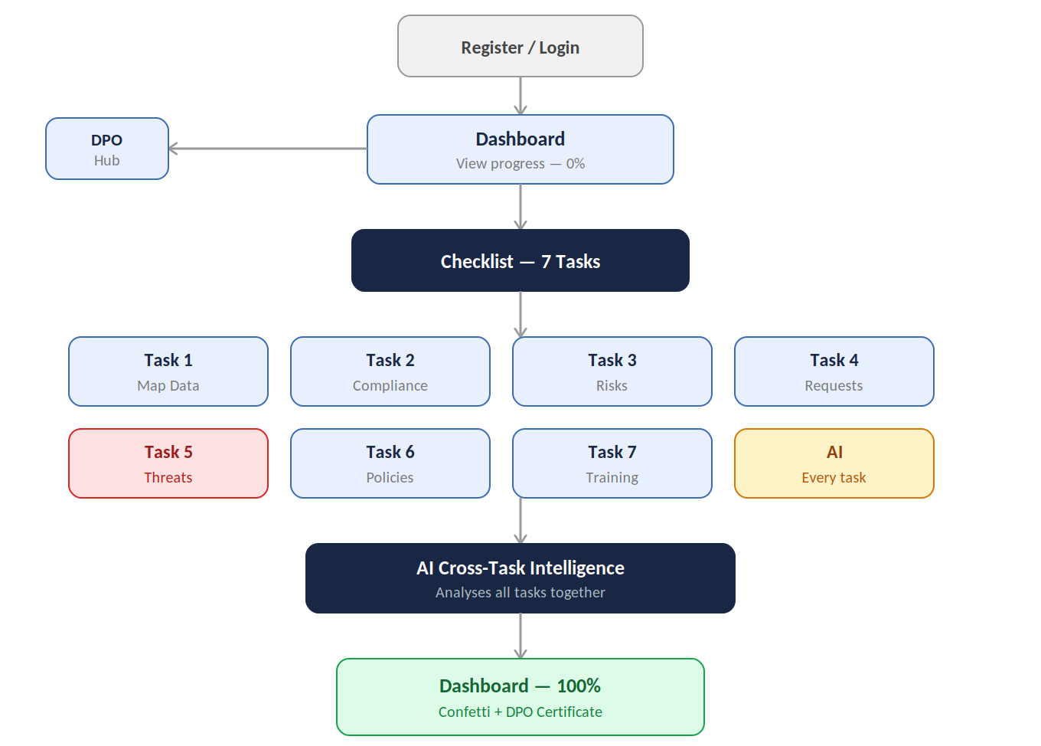

Figure 4: User workflow diagram

Before describing each feature in detail, the diagram below shows the overall user workflow throughout the system. A new user registers and arrives at the dashboard which shows 0% progress. From there they can visit the DPO Hub to learn about the role or go straight to the checklists and start working through seven tasks. AI is integrated into every task, providing analysis and recommendations based on the user’s actual data. Once all seven tasks are complete, the AI cross tasks intelligence analyses everything together. The dashboard then shows 100% compliance with a confetti celebration and a downloadable DPO certificate.

System Implementation
The final system is a working web application that lets a user perform all seven core responsibilities of a Data Protection Officer through interactive tools. This section walks through each part of the system with screenshots showing how it actually looks and works.

Landing Page and Authentication
When a user first visits the application, they see a landing page that explains what the system does and who it is for. The page has a clear call to action to either register or log in. Figure 5 shows the landing page.
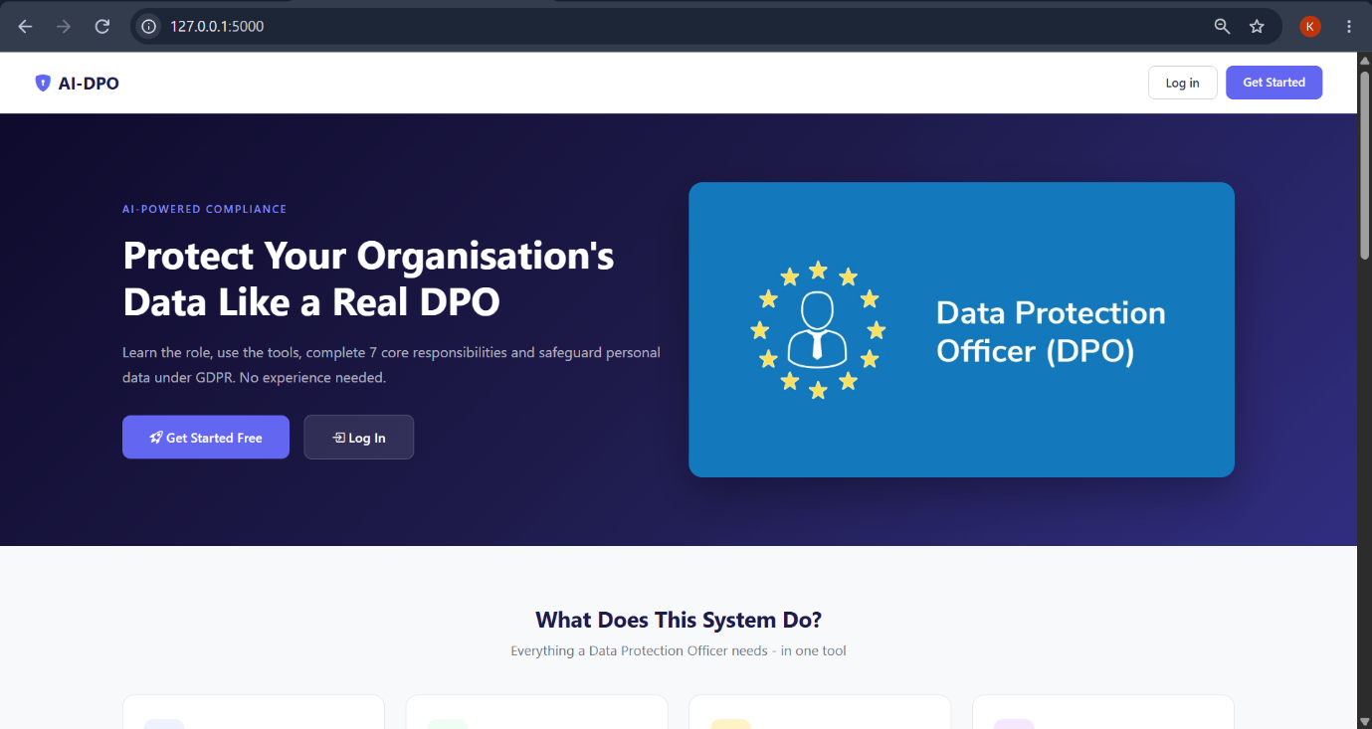

Figure 5: landing page

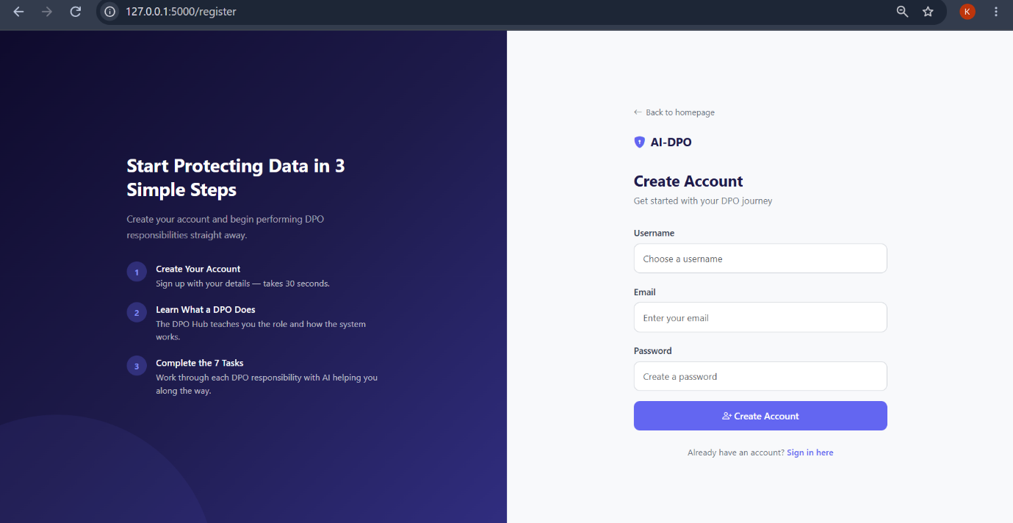

Figure 6: Registration page

New users register with a username, email and password. Passwords are hashed using Werkzeug before being stored in the database. This means even if someone accessed the database directly, they could not read the passwords. Flask-login handles user sessions, so the system remembers who is logged in. Figure 6 shows the registration page.

Dashboard
After logging in, users see the main dashboard. This is the control centre of the application. It shows four key metrics at the top: compliance score, tasks completed, open incidents and total incidents. Below that is the full checklist of seven tasks showing which ones are done and which still need doing. On the right side there is an SVG gauge that shows the compliance percentage visually. The figure below shows the dashboard for a new user with no tasks completed.
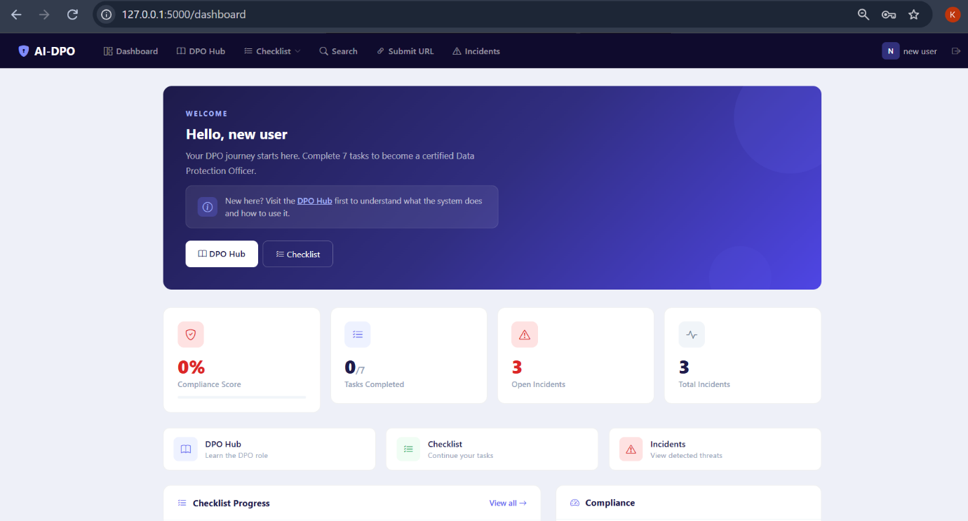
Figure 7: Dashboard for new user

The dashboard also has a stakeholder impact section. This was added after supervisor feedback about the system needing to show who is affected by the DPO’s work. It has four cards; management, staff, data subjects and regulators. Each card lists the tasks that are relevant to that stakeholder group and shows whether they are complete. Figure 8 shows the stakeholder section.

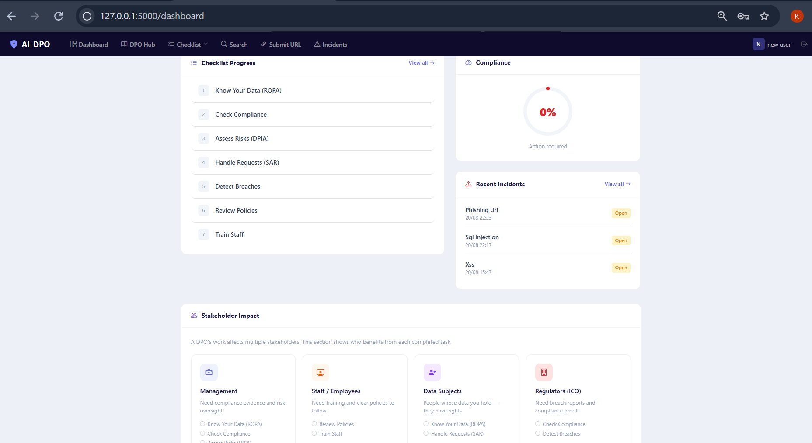

Figure 8: Stakeholder impact section
When a user completes all seven tasks, the dashboard changes. Confetti fall across the screen to celebrate the achievement, and a green banner appears offering a downloadable DPO certificate.

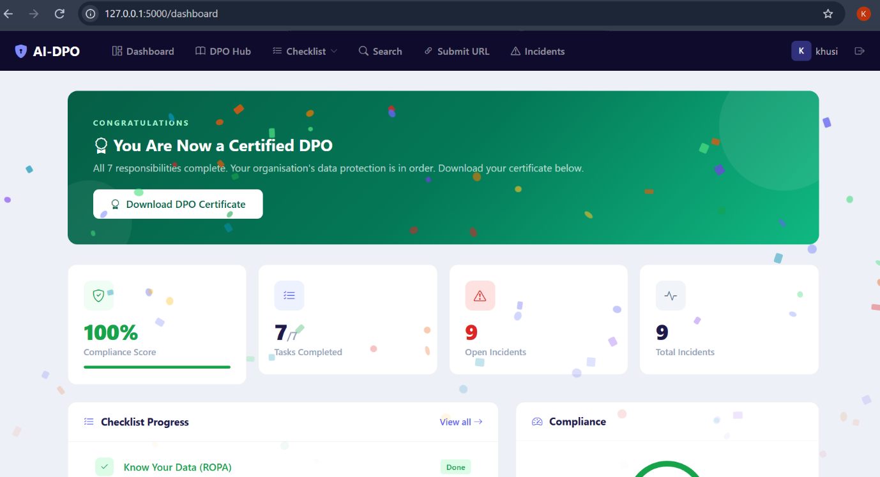

Figure 9: Dashboard at 100% showing confetti and downloadable certificate

DPO hub
The DPO hub is an educational page that explains the role of a Data Protection Officer. It is designed to be the first place a new user visit. It has full width hero section, stat cards showing key facts about data protection, detailed descriptions of each of the seven tasks, a side by side image section and an FAQ accordion. This page does not require any input from the user; it is purely informational.
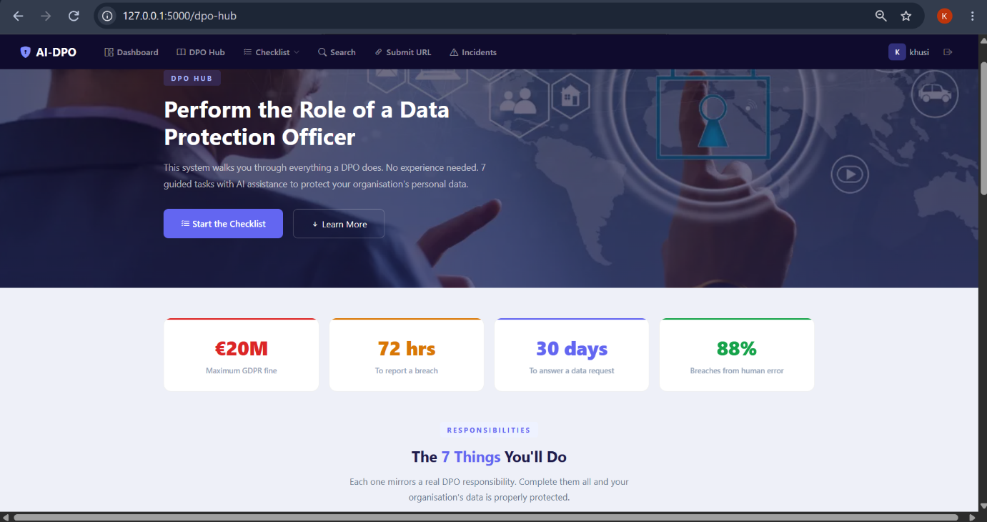
Figure 10: DPO hub page

Requirements Traceability
The table below maps each functional requirement back to the feature that implements it and the figure in this report that shows its working. This demonstrates that all requirements identified in the Methodology chapter have been met.
ID | Requirement | Evidence
FR1 | Secure login/register | Figure 6
FR2 | Detect 5 attack types | Table 1 (test results)
FR3 | AI auto classification | Figure 23
FR4 | Data inventory + AI | Figure 12, 14
FR5 | Compliance check + AI | Figure 15, 16
FR6 | Risk assessment + AI | Figure 17, 19
FR7 | Request tracking | Figure 20
FR8 | Policy management + AI | Figure 26, 27
FR9 | Training + quizzes | Figure 28, 29
FR10 | PDF breach reports | Figure 25
FR11 | PDF inventory reports | Task 1 PDF button
FR12 | Cross task AI | Figure 31
FR13 | Dashboard + stakeholders | Figure 7, 8

Table 3: Requirements traceability table

All 13 functional requirements have been implemented and are shown through the screenshots and test results in this chapter. The nonfunctional requirements were also checked. Passwords are hashed using Werkzeug. The API key is stored in .env and excluded form Git. Pages load within seconds. All text uses simple terms and words. AI responses are saved in database, so they are not regenerated unnecessarily.

Task 1 – Map your Data
Task 1 lets user build a complete inventory of the personal data their organisation holds. This is one of the first things a real DPO would do because you cannot protect data you do not know about. There are two ways to add data to the inventory. The first is the quick start feature where the user picks an organisation type from a dropdown., like Retail or Healthcare and the AI generates a set of typical data entries for that type. The second is a manual form where the user fills in details like what data is held, why it is collected, who has access, how long it is kept and how it is protected.

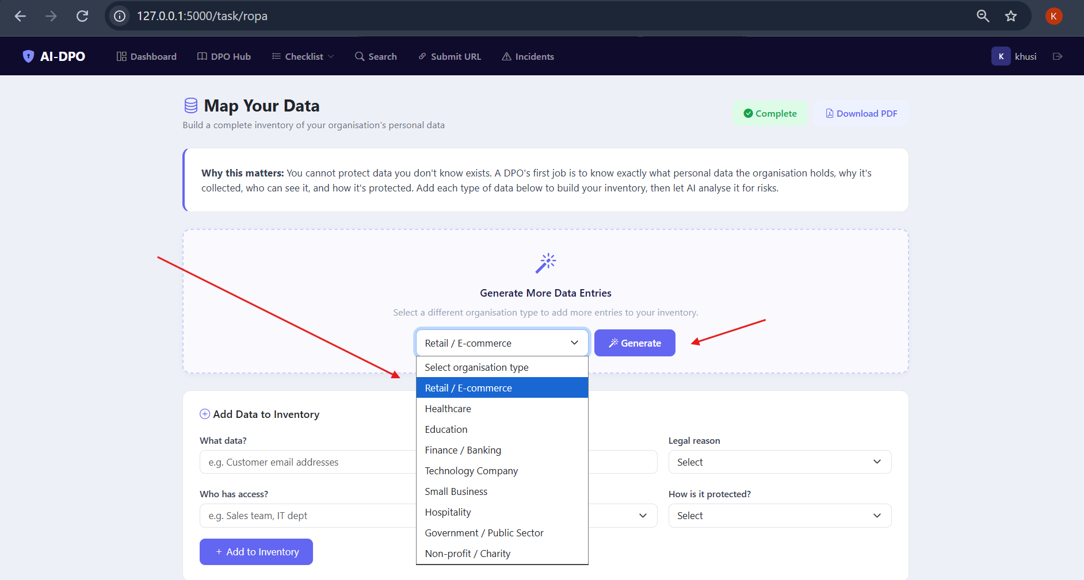
Figure 11: Auto generate dropdown option
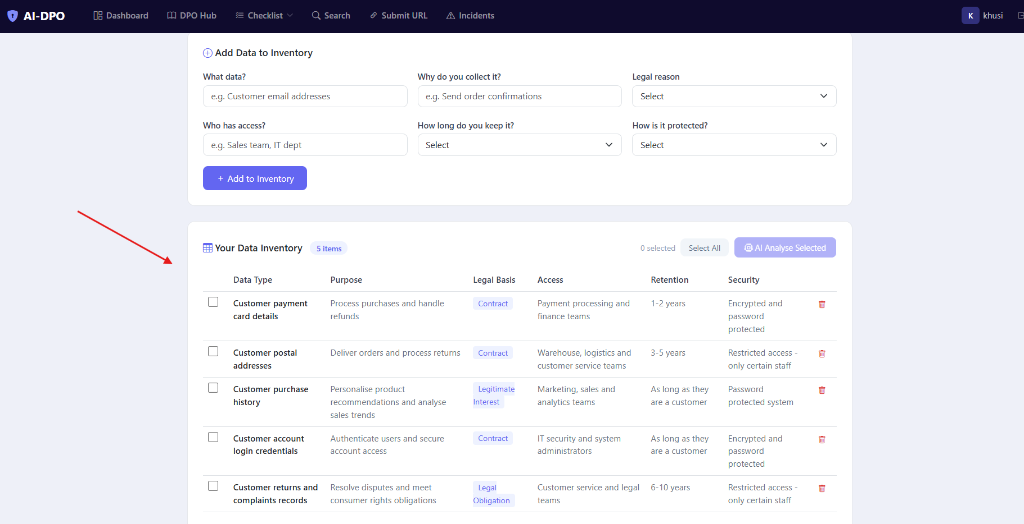
Figure 12: Inventory table with generated data

Users can select entries using checkboxes and click the AI analyse button to get a risk assessment. The AI reads the selected entries and gives specific feedback about risks and gaps. For example, if the data includes customer payment details with weak security, the AI will flag that specifically. There is also a bulk delete feature where users can select multiple entries and delete them at once.
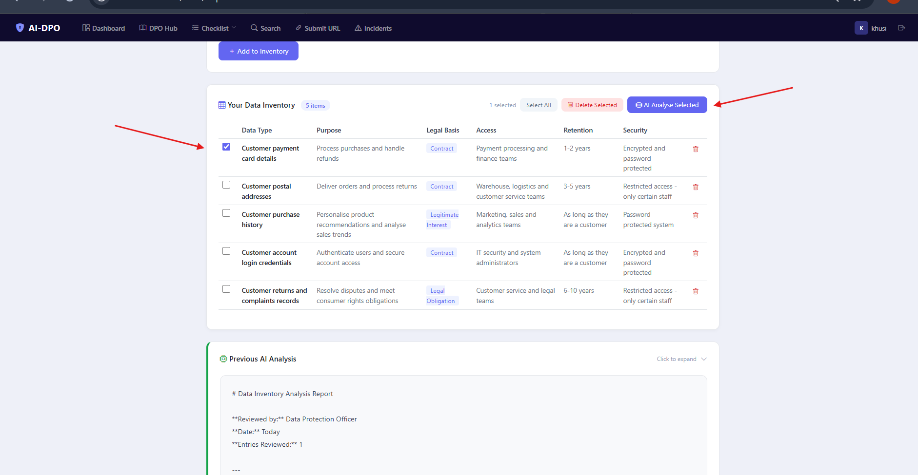
Figure 13: Bulk deletion of data plus ai analyse button

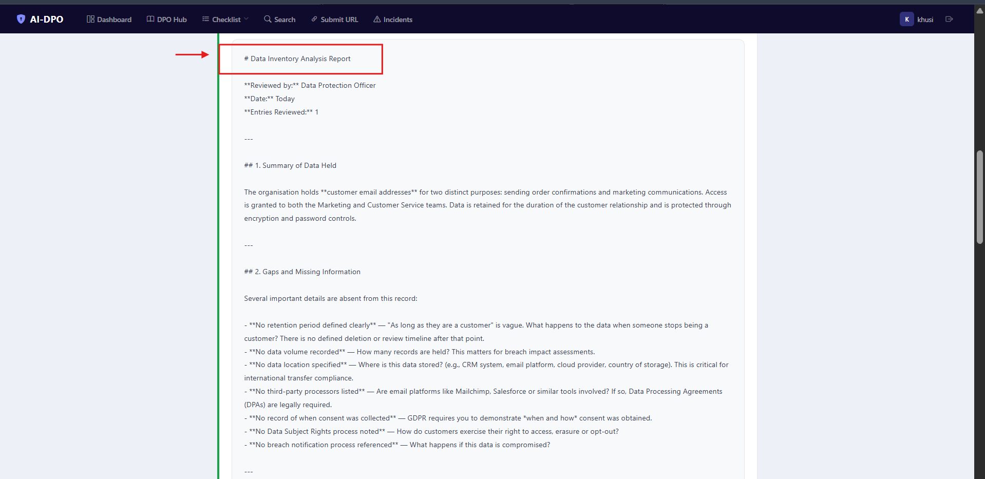

Figure 14: AI analysis

A PDF exports button lets users download the full inventory as a formatted report. This is useful because a DPO needs to be able to share the data inventory with management or regulators.

Task 2 – Check Your Practices
Task 2 is a compliance checker. The user answers eight questions about how their organisation handles personal data. The questions over data minimisation, lawful basis, consent, data accuracy, retention, security measures, breach processes and whether a DPO has been appointed. Each question has three options: Yes, partially or no. The system calculates a percentage score based on the answers.
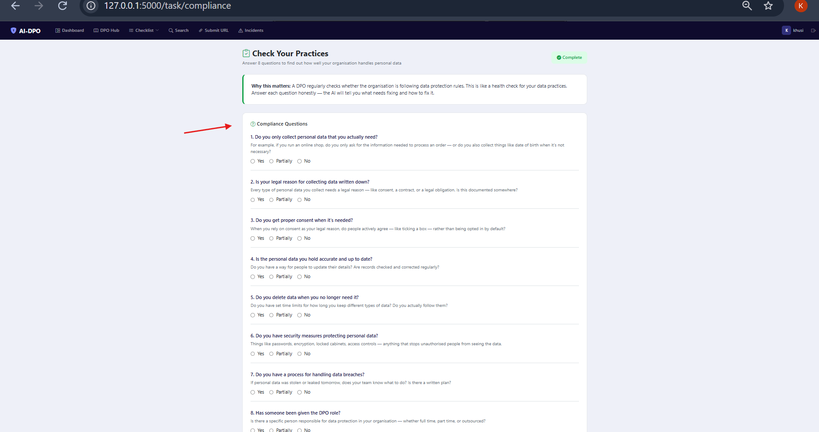
Figure 15: Compliance questions for task 2

After submitting, the AI gives a formal compliance assessment. It rates the organisation as Strong, Adequate or Needs Improvement, lists areas of concern, highlights areas of strength and gives a recommended next step. There is a retake button so the user can redo the check after making improvements.
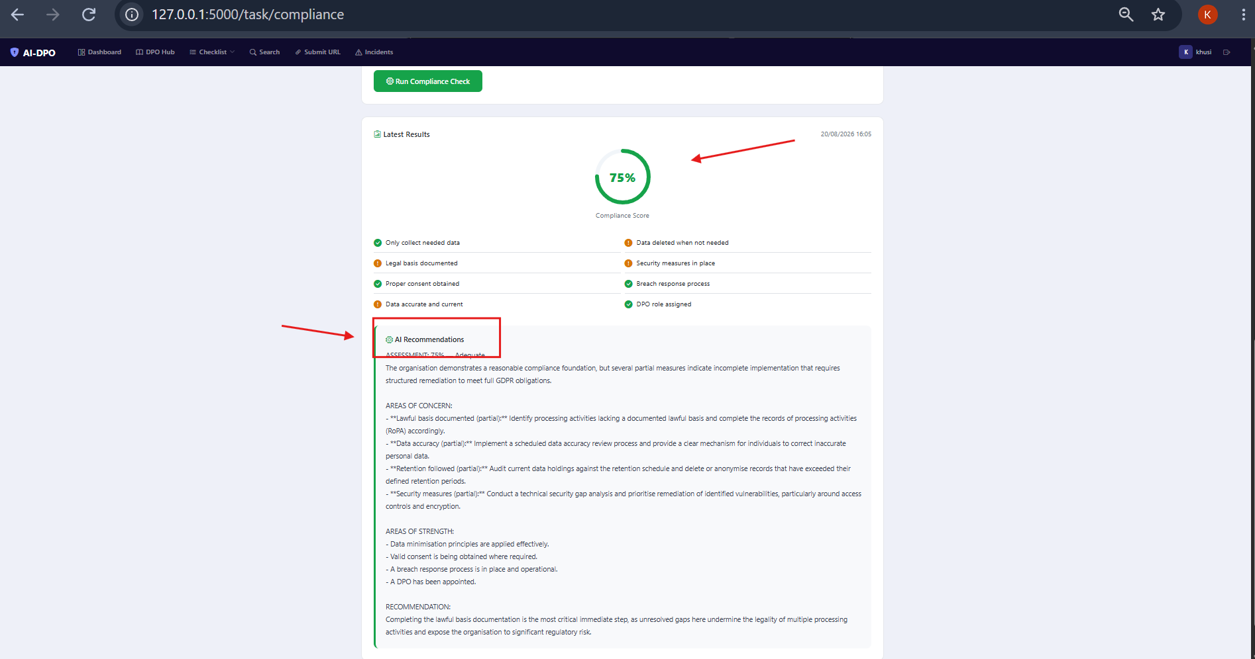
Figure 16: Score and AI assessment

Task 3 – Assess Risks
Task 3 is a Data Protection Impact Assessment tool. Instead of making users fill in a long form, it uses guided selectors that make it easy and quick. The user clicks a project type button, selects data type chips that are colour coded by risk level (green for low, amber for medium, red for high), chooses the scale of the project, and answers yes/no questions about third party sharing and intentional transfers. As the user makes selections, a live risk meter at the bottom of the page updates in real time using JavaScript. This gives instant visual feedback before the AI even runs.
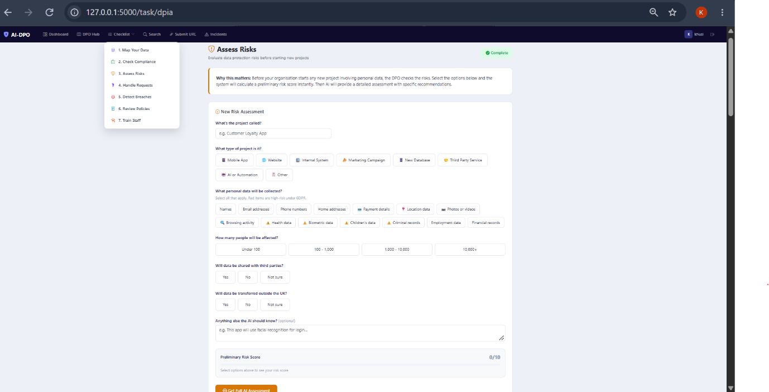
Figure 17: guided selectors for task 3
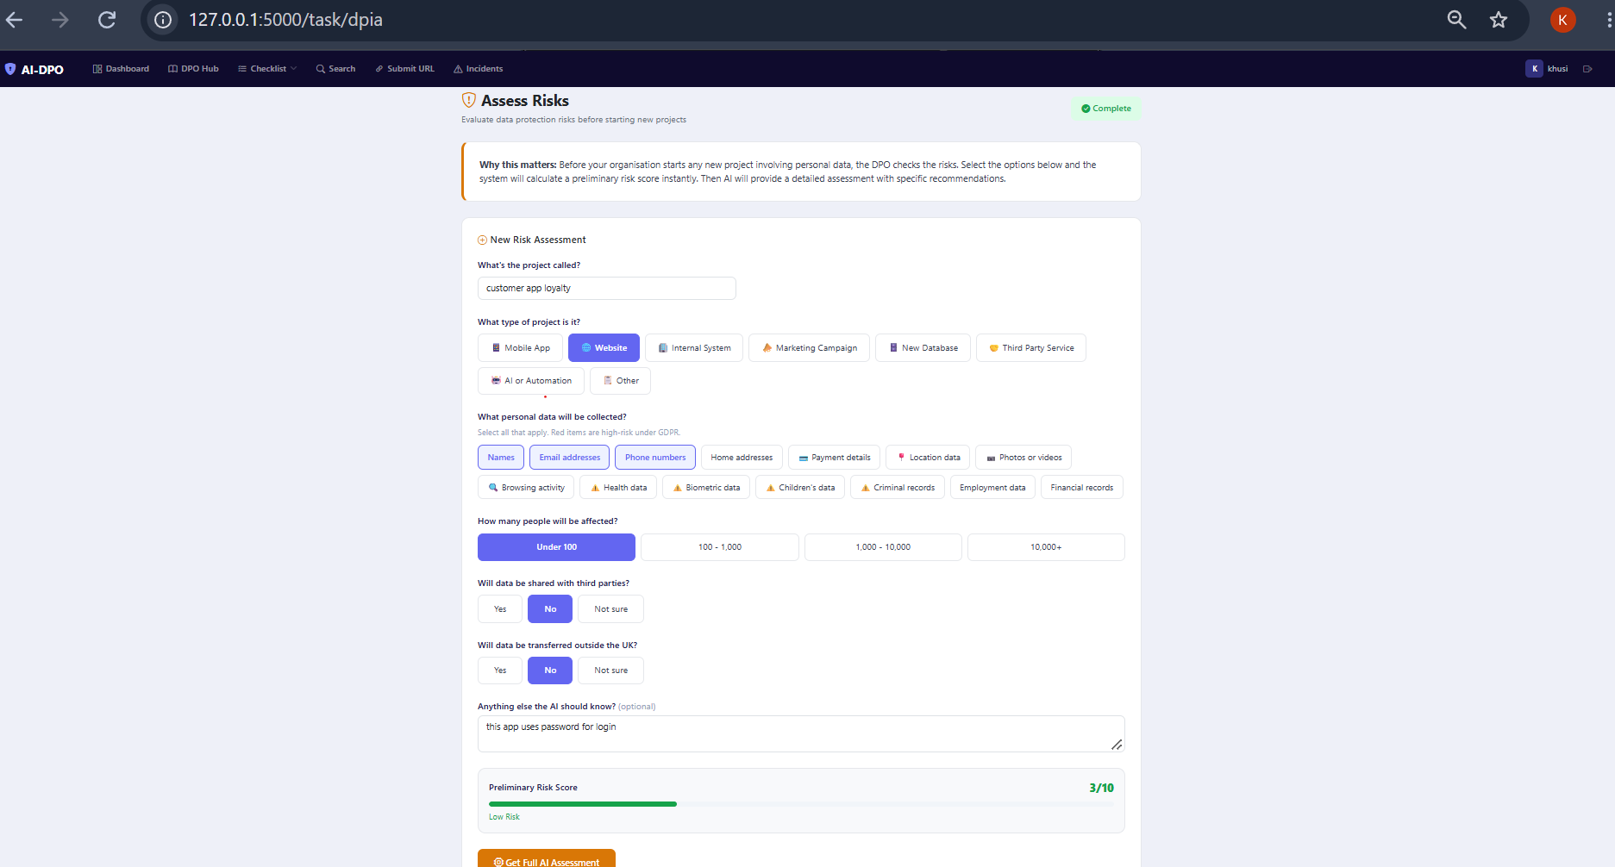
Figure 18: Live score meter or risk meter
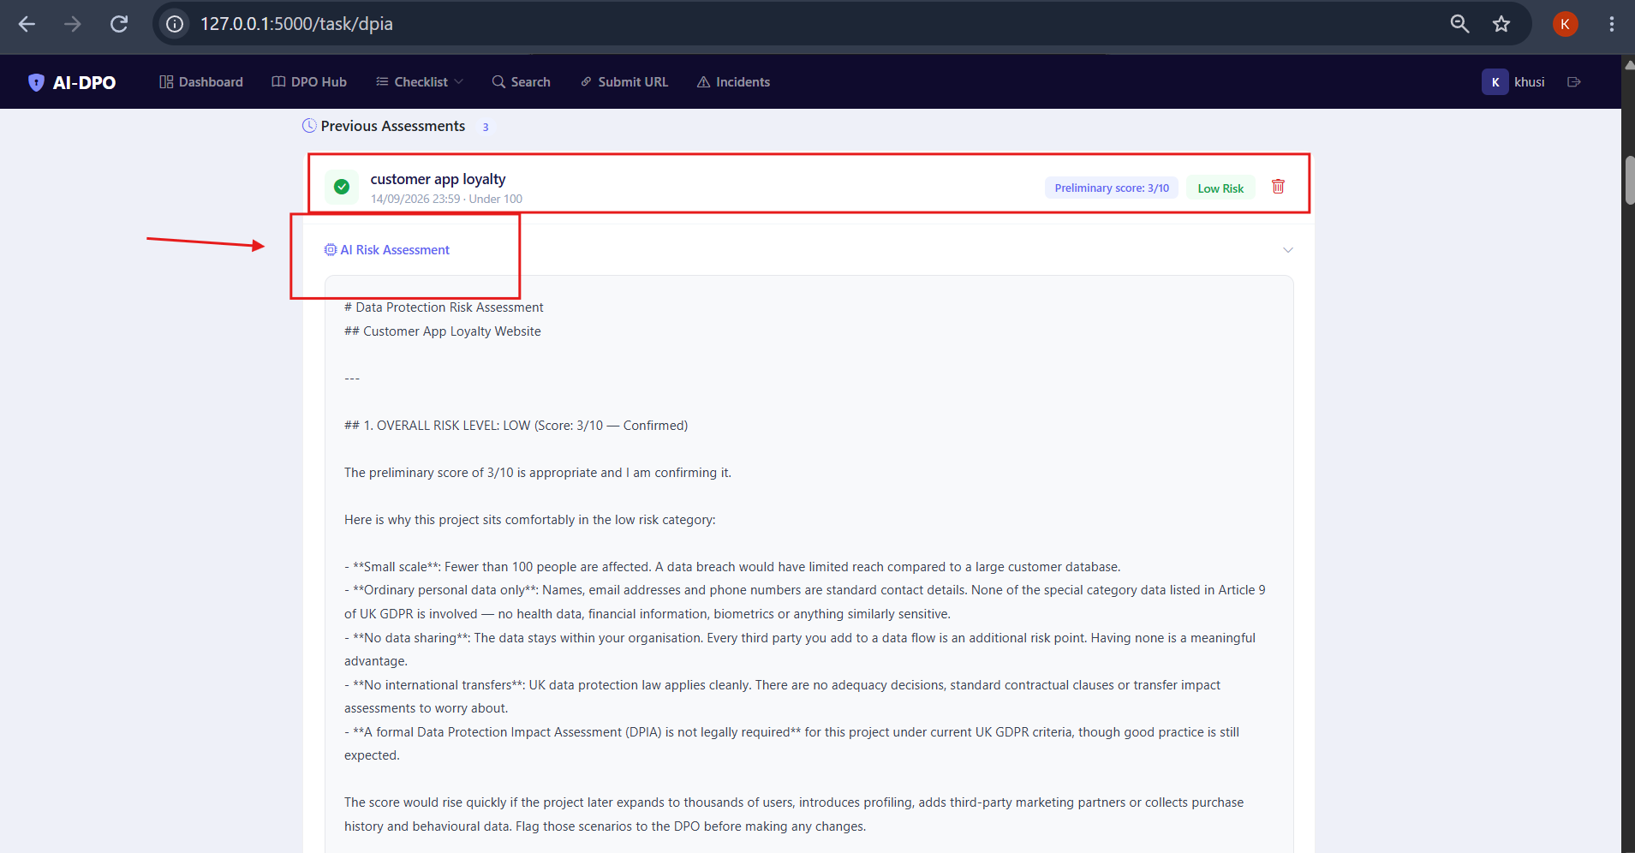
Figure 19: AI risk assessment result

When the user submits the assessment, the AI does a full risk evaluation based on the selections. It explains the risk level, identifies specific concerns and recommends safeguard that should be put in place.

Task 4 – Handle Requests
Task 4 is a request tracking system for handling data subject access requests. Under GDPR, organisations must respond to these requests within 30 days. The system has two ways to add requests. The AI can generate three realistic requests at once for practice, or the user can log request manually. Each request shows a 30 day countdown bar that changes from green to amber to red as the deadline gets closer. Figure 20 shows the request list with countdown bars.
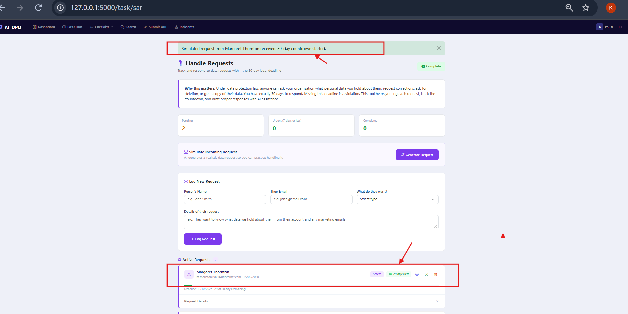
Figure 20: Requests with countdown bars

The user can click an AI button on any request to get a professional draft response letter. The AI writes a complete response based on the request type. Requests can be marked as complete, reopened or deleted. The figure below shows an AI drafted response.
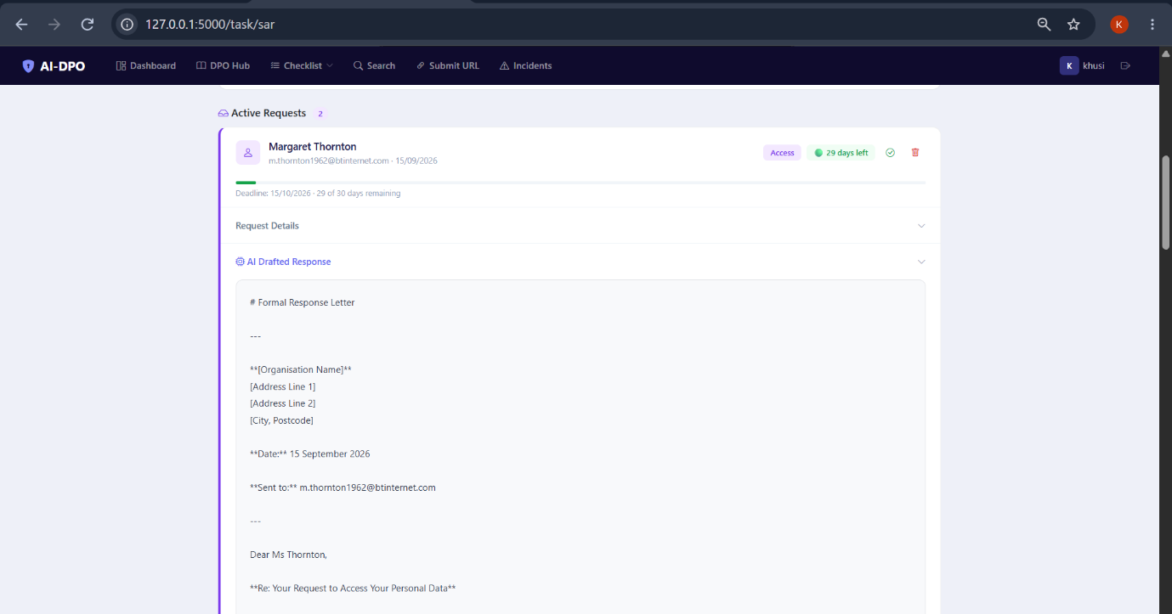
Figure 21: AI draft response letter

Task 5 – Monitor threats
Task 5 is the breach detection and monitoring tool. It has a test box where users can type attack payloads to see the detection engine in action. Example attacks area shown on the page, so users know what to try. When a threat is detected, the system creates an incident, and the AI automatically classifies it. There is no classify button, it happens instantly. This is the auto classify feature. The AI classification includes the severity level (critical, high, medium or low), whether the incident is reportable under GDPR article 33 and specific recommendations for what the DPO should do.
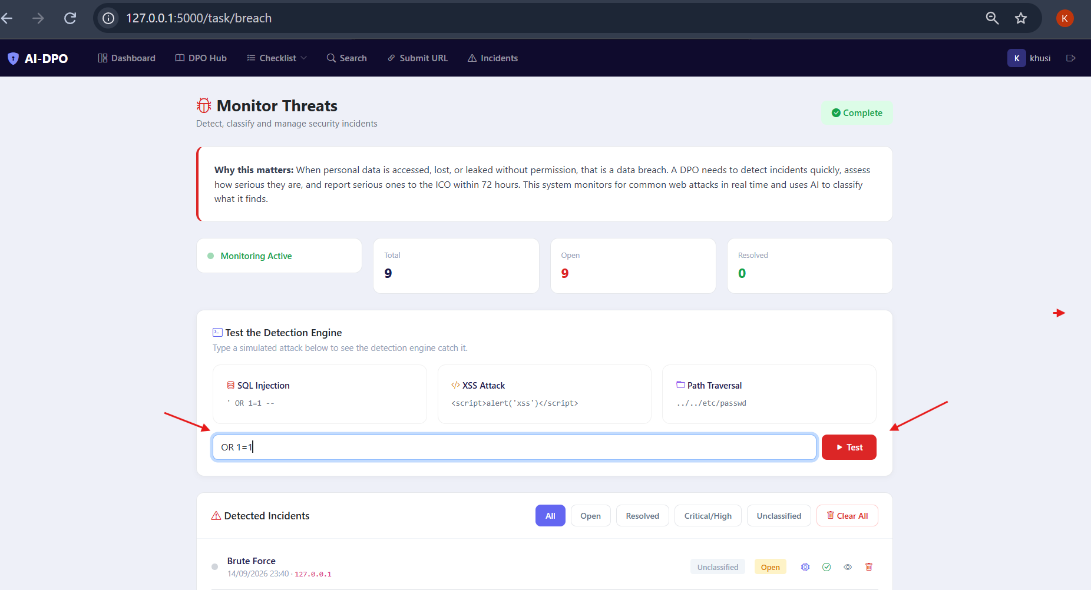
Figure 22: Test box with SQL injection typed

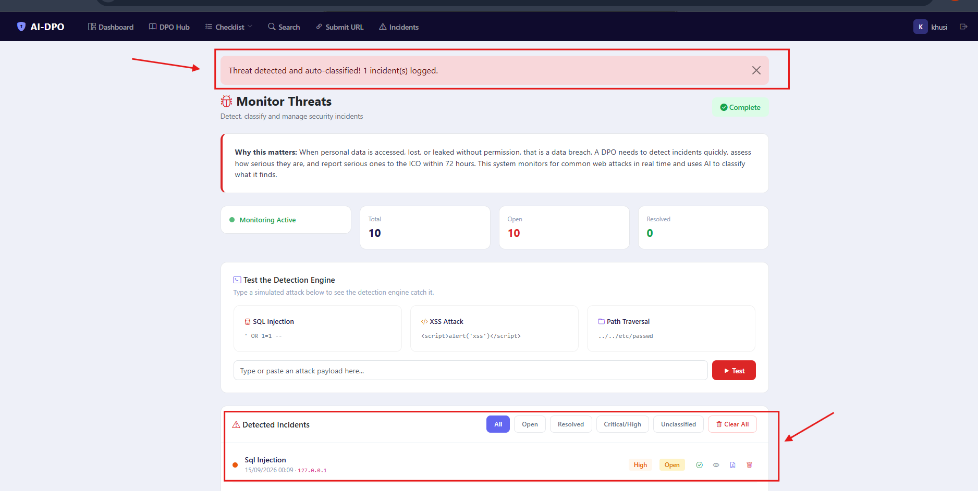
Figure 23: Threat logged and auto classified

The incident page has filter buttons for all, open, resolved, critical/high and unclassified. Each incident can be resolved, reopened or deleted. Users can also download a PDF article 33 breach report for any classified incident. This report includes all the fields that the ICO requires when notifying them of a data breach. The two figures below show incident list with filter and other shows a downloaded PDF breach report.
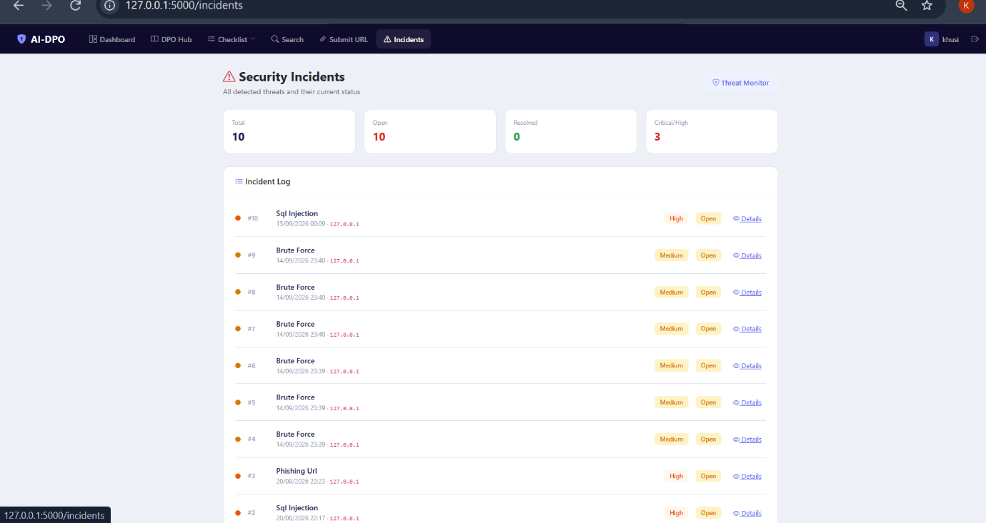
Figure 24: Incident page lists
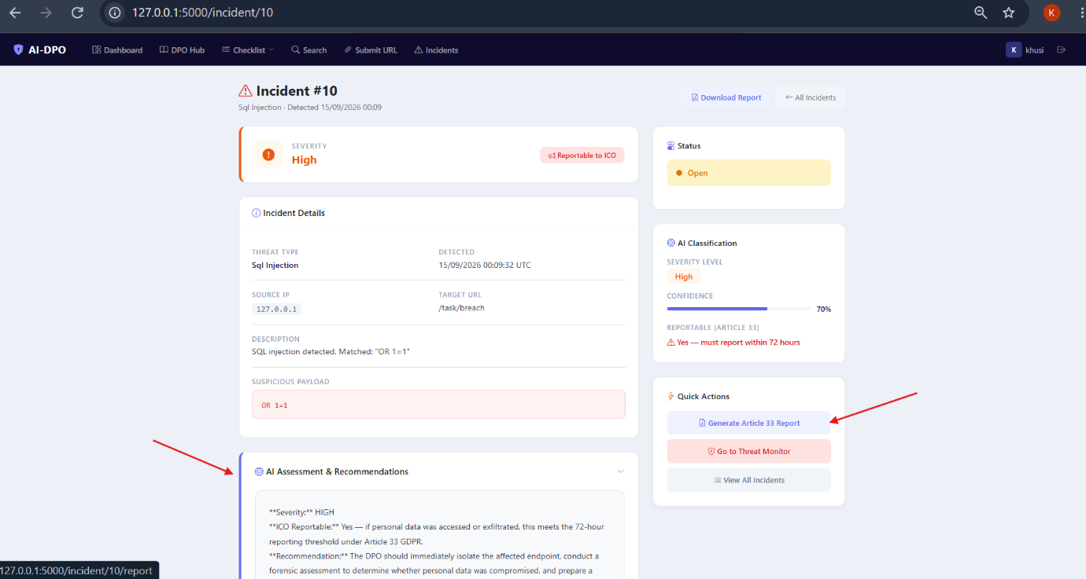
Figure 25: PDF breach report, with all the incident details

It is important to note that the detection engine does not only run in the test box. It scans user inputs across the entire application, the search page, the submit URL page, the login form and the registration form. This means the system is always monitoring for threats in the background, which is how a real monitoring system would work.

Task 6 – Manage policies
Task 6 lets users create and review data protection policies. There are six policy templates available as clickable cards: Privacy policy, data retention policy, breach response policy, access control policy, acceptable use policy and data subject rights policy. When the user clicks a template, the AI writes a complete policy. Users can also write their own policy from scratch using a text area. Figure 26 shows the policy template cards.
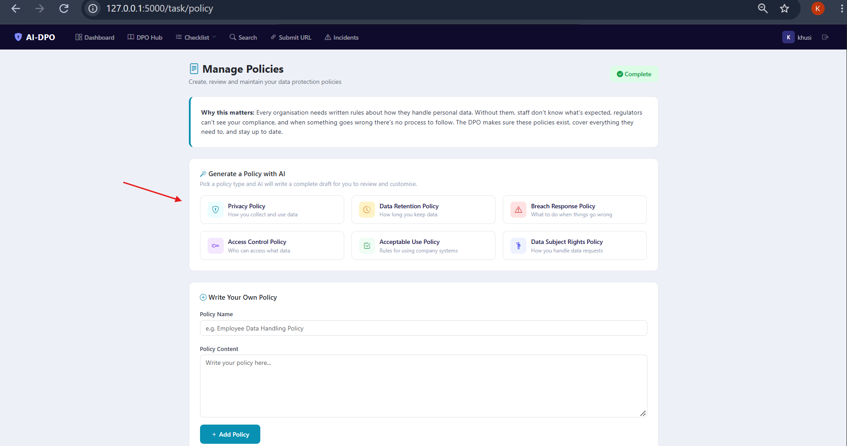
Figure 26: Policy generation using ai or manual creation

Once a policy exists, the user can click an AI review button. The AI reads the policy and gives a brief assessment, rating it as Strong, adequate or needs improvement. It lists what is good and what needs fixing. The figure below shows a generated policy with its AI review.
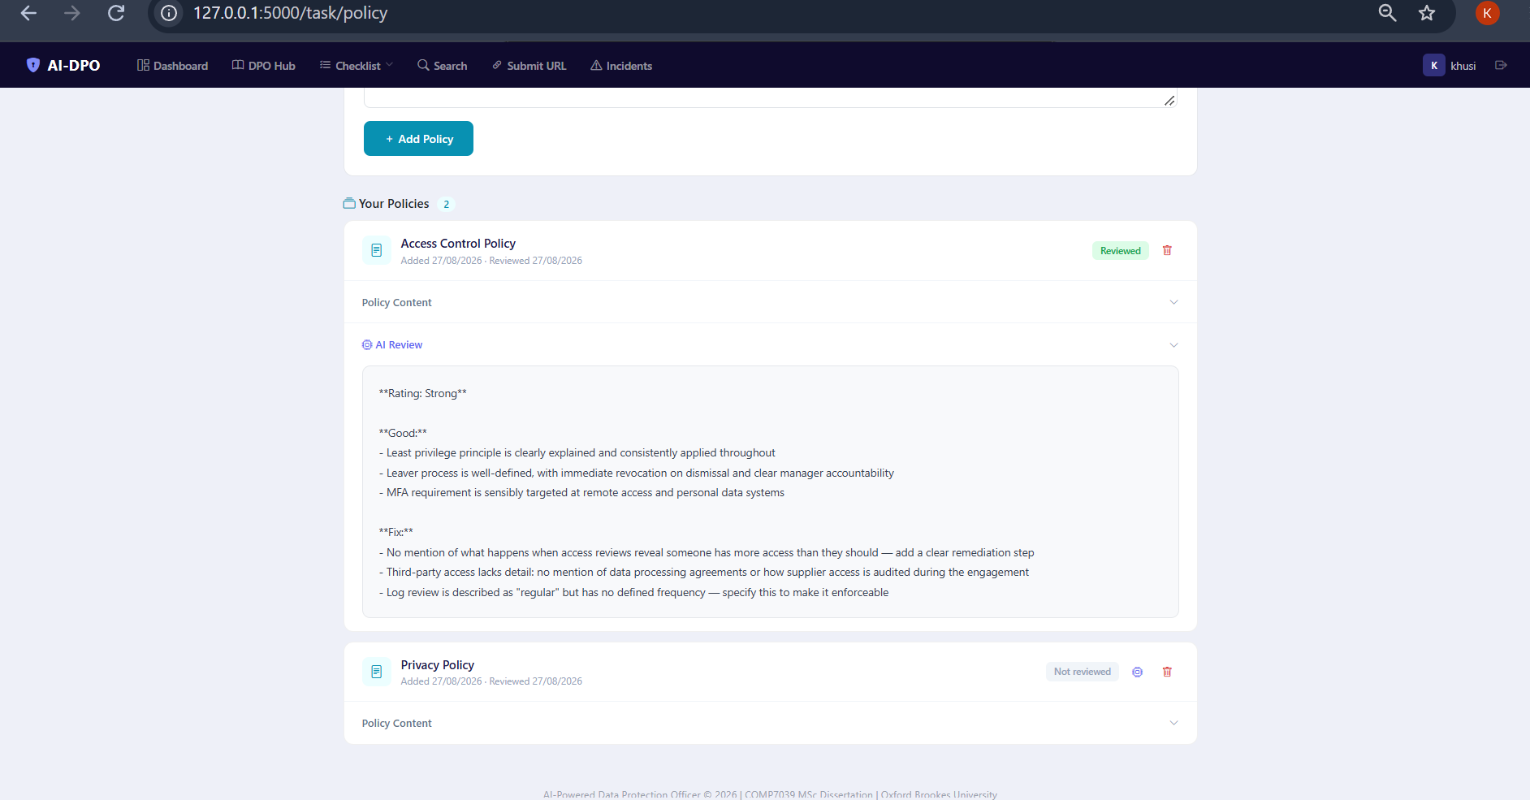
Figure 27: Generated policy with AI review

Task 7 – Train your team
Task 7 generates interactive training modules. The user picks a topic from a dropdown with eight options, like Data Protection Basics, spotting phishing emails or password security. The AI creates six flip cards that shows a question on the front and the answer on the back when clicked. After going through the cards, the user takes a five question multiple choice quiz.

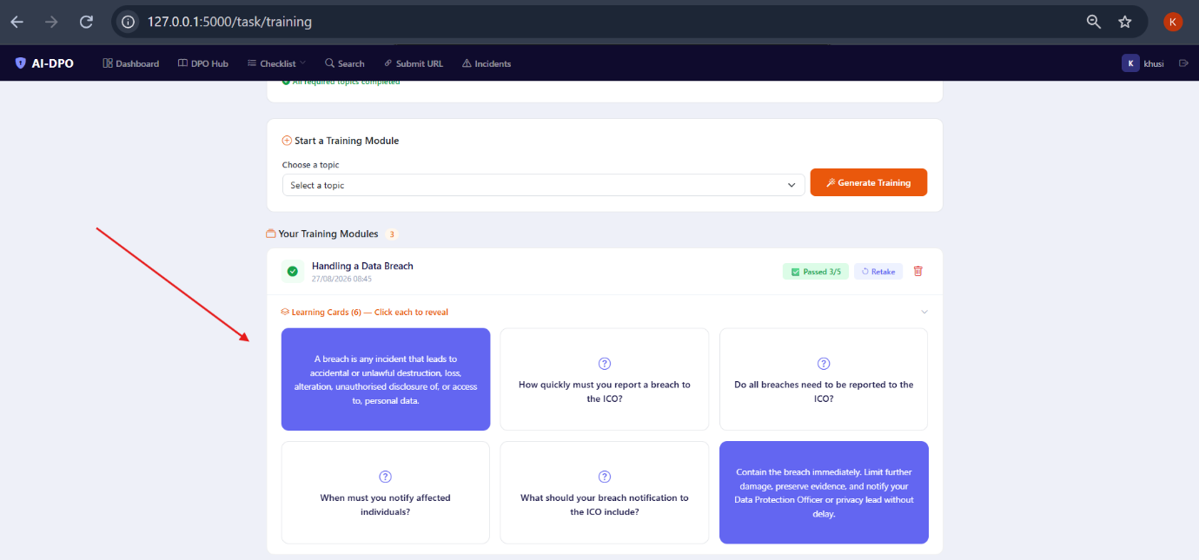
Figure 28: Flip cards for different modules
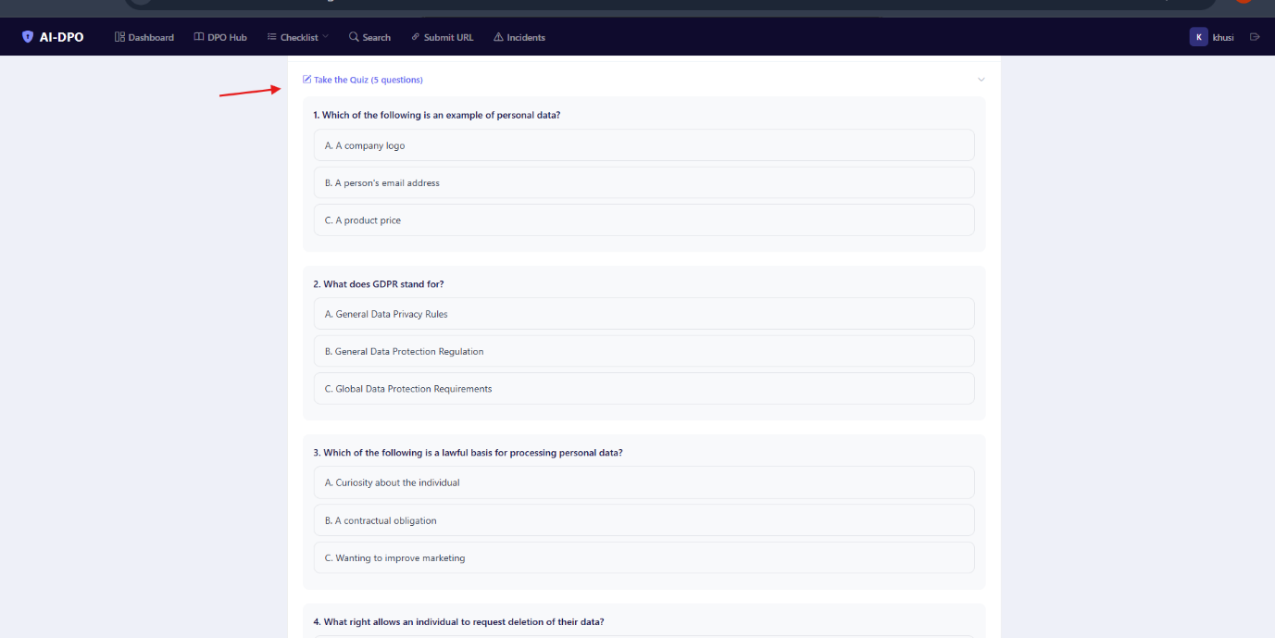
Figure 29: Quiz questions

To complete task 7, the user must pass three different topics with a score of 60% or above. A progress bar at the top shows how many topics have been passed out of three. This was designed this way because a real DPO needs to ensure staff are trained across multiple areas, not just one. There is retake button for both passed and failed quizzes.
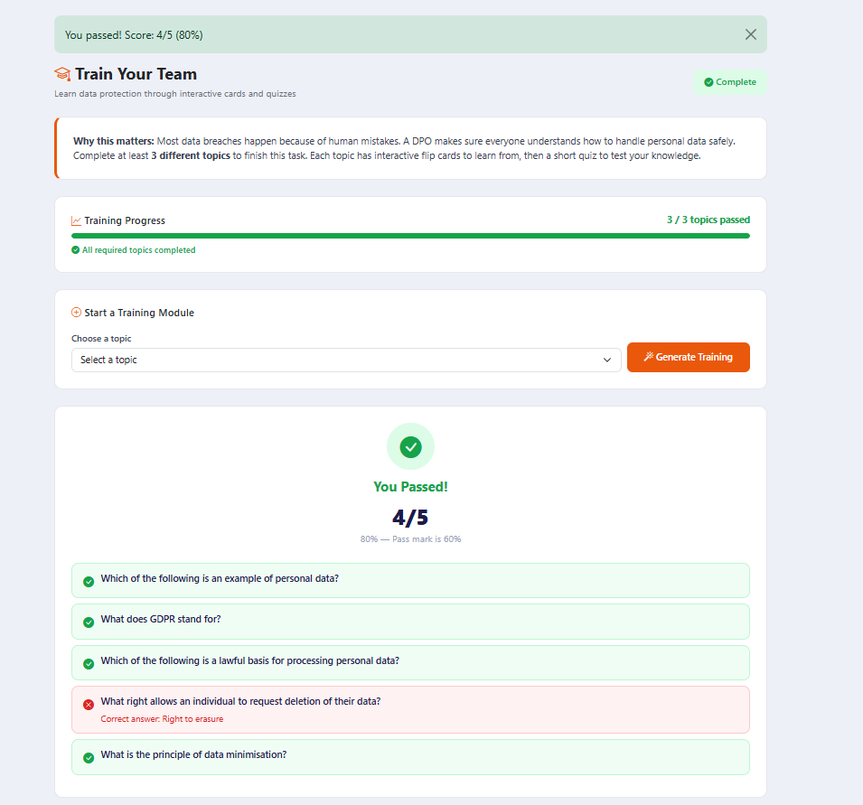
Figure 30: Quiz results and progress bar

AI cross task intelligence
One of the more advanced features is the AI cross task intelligence page. When the user has completed at least two tasks, a button appears on the dashboard. Clicking it gathers data from every completed task and sends it all to the AI in one prompt. The AI then finds risks that would not be visible by looking at each task on its own. For example, it might notice that the data inventory has payment data but there is no breach response policy, or that there are open incidents, but staff have not been trained on breach handling. This feature shows the value of having AI that can look at the bigger picture. The figure shows cross task intelligence results.
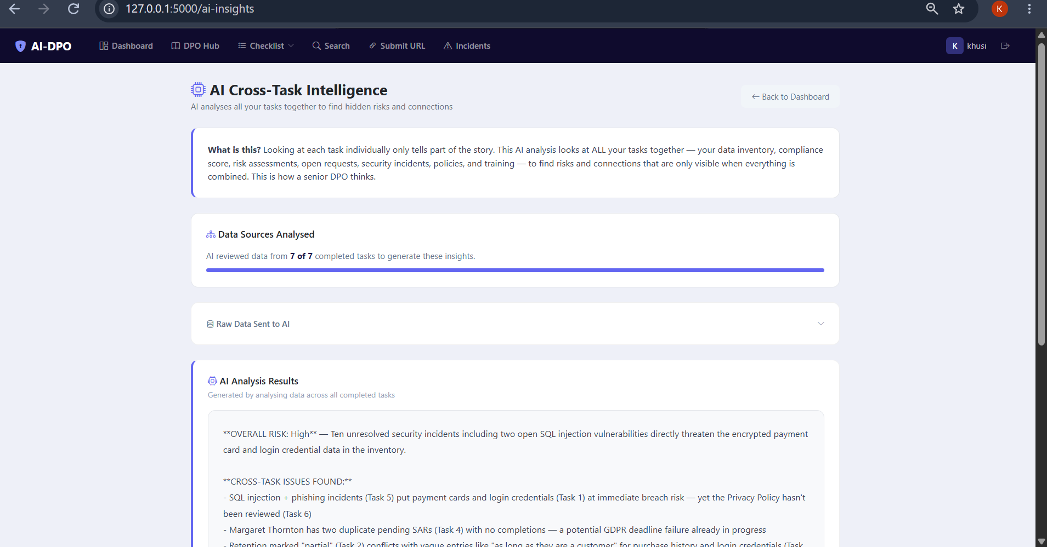
Figure 31: AI cross task insights results

Detection Engine
The detection engine is the core security component of the system. It is in the file app/utils/detection.py. it uses regular expressions to scan user inputs for known attack pattern. It detects five types of web application threats:
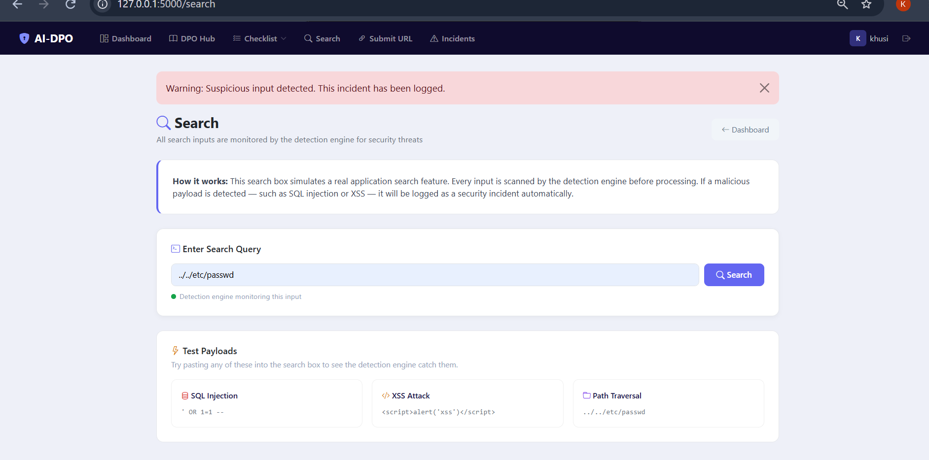
Figure 32: Search page detecting attack

SQL injection, it looks for pattern like single quotes followed by OR statements, UNION SELECT commands, DROP TABLE attempts and comment sequences. Cross site scripting (XSS), it catches script tags, Javascript event handlers like onerror and onload, and encoded script injection. Path traversal, it detects sequences like ../ and attempts to access system files such as /etc/passwd. Phishing, it checks for IP based URLs and known URL shortener domains. Brute force, it counts failed login attempts from the same IP address within five minutes and flags it after five failures.
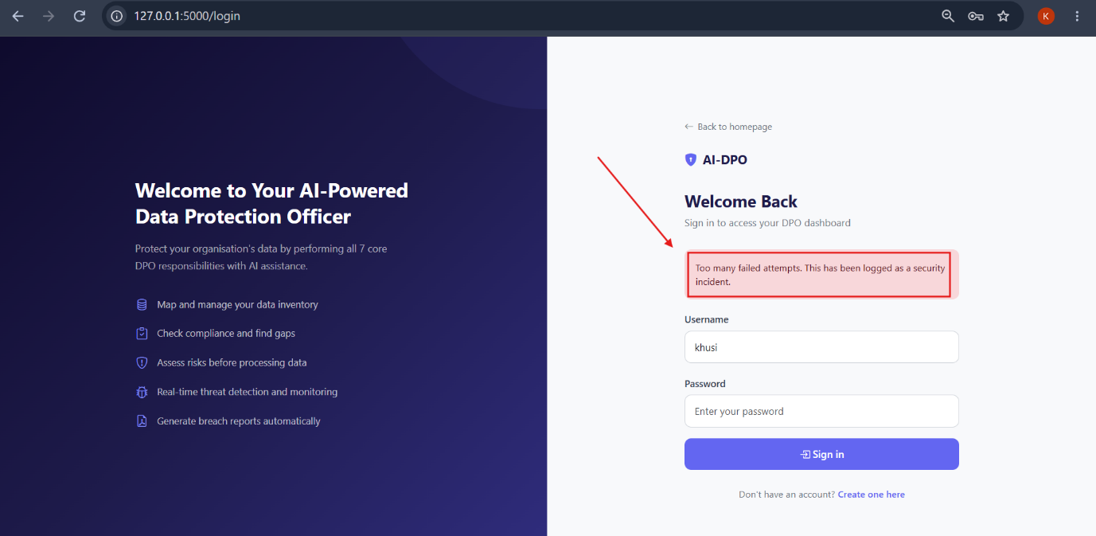

Figure 33: Brute force detection

Testing and Evaluation
The system was tested through manual testing and simulated attack scenarios. Every feature was tested by going through the complete user flow from start to finish. This section presents the key test results.

Detection Engine Testing
Each of the five attack types was tested with multiple payloads. Table 1 shows the test results for the detection engine.

Attack Type | Test payload | Detected | AI Severity
SQL injection | ‘ OR 1=1 -- | Yes | High
SQL injection | UNION SELECT * FROM users | Yes | Critical
XSS | <script>alert(‘xss’)</script> | Yes | High
XSS | <img onerror=alert(1)> | Yes | Medium
Path traversal | ../../etc/password | Yes | High
Path traversal | ..\windows\system32 | Yes | Medium
Phishing | http://192.168.1.1/login | Yes | Medium
Phishing | http://bit.ly/suspicious | Yes | Low
Brute Force | 5 failed logins in 2 minutes | Yes | High
Brute Force | 3 failed logins in 5 minutes | No | N/A

Table 4: Detection engine test results

All five attack types were successfully detected. The only case where detection did not trigger was the brute force test with only three failed attempts, which is correct because the threshold is set at five attempts within five minutes. The AI severity classifications were consistent and appropriate for each attack type.

AI Response Evaluation
The AI responses were checked for relevance and usefulness. In every case, the AI gave advice that was specific to the actual input, not just generic text. For example, when analysing a data inventory containing customer payment details with no encryption, the AI specifically flagged the payment data as high risk and recommended encryption. When classifying a SQL injection incident, the AI correctly identified it as a serious threat and recommended immediate investigation of the affected database. The AI cross task intelligence was also tested by completing multiple tasks and checking whether the AI could find connections between them. After completing Task 1, 2 and 5, the AI correctly identified that the organisations had sensitive data in its inventory but a low compliance score, and that there were open incidents that needed attention before the compliance could improve.

Limitations
There are some limitations to acknowledge. First, the detection engine uses pattern matching, which means it can only catch attacks that match known patterns. A highly customised or obfuscated attack might get through. Second, the system has not been tested with real users outside of the developer. A proper usability study with participants would strengthen the evaluation. Third, the system depends on the Claude API being available. If the API is down or the account runs out of credits, the AI features stop working. These limitations are noted as areas for future improvement.

Project Management
The project was managed using Agile sprints, with each sprints lasting roughly 3-4 or week even. Table below shows the sprint breakdown with what was done in each one.
Sprint | Date | Work Completed
Sprint 1 | May – June 2026 | Topic selection, proposal submission, literature review and background research.
Sprint 2 | July 2026 | Research on GDPR requirements, DPO role analysis, reviewed existing tools
Sprint 3 | August 2026 (week 1) | Finalised technology stack, Project setup, Flask structure, user authentication
Sprint 4 | August 2026 (week 2) | Detection engine, all DPO tasks built, PDF report generation, dashboard and checklist
Sprint 5 | August 2026 (Week 3) | Dashboard redesign, DPO centre, stakeholder section, AI cross task intelligence, certificate, UI polish across all pages, report writing started
Sprint 6 | August – September 2026 | Bug fixes, testing, report writing, presentation preparation
Table 5: Sprint breakdown showing development progress
The first two sprints focused on research and planning. This included writing the proposal, reviewing academic literature, analysing GDPR requirements, studying the DPO role in detail and evaluating existing tools to understand the research gap. The actual development began in August 2026, with the system being built over three intensive sprints. This approach meant that by the time coding started, the requirements were well understood, and the design decisions had already been though through.

Supervision meetings were held every Thursday via Google meet. Each meeting lasted about 30 minutes. These meetings served as sprint reviews where progress was shown and feedback was collected. The feedback directly shaped what was built in the next sprint. For example, after meeting 3 the supervisor said the system was too basic and needed a task checklist. This was built in the following sprint. After meeting 4, stakeholder awareness and AI depth were added. All meetings are recorded in the meeting log document shared with supervisor on Google Drive.

Version control was managed through Git with a Github repository at https://github.com/khusigit11/AI-powered-DPO. Commits were made regularly throughout development. The commits history shows consistent progress from initial setup through to the final version. The repository link is also included in the appendices.

Project data was managed using Google Drive for meeting logs, report drafts and literature. The final report was also given access to supervisor in Microsoft one drive.

Risk Analysis
Several risks were identified at the start of the project, and some new ones came up during development. Table below shows the risks, their impact and how they were handled.

Risk | Likelihood | Impact | How it was managed
Scope creep – project grew beyond original proposal | High | High | Managed through agile sprints. New features added in controlled sprints rather than all at once.
API dependency – system relies on Claude API | Medium | High | Kept prompts short to minimise usage. Stored AI responses in database so they are not regenerated.
Time pressure – development period shorter than planned | High | Medium | Prioritised features by impact. Built most important tasks first.
Data Security – handling simulated personal data | Low | High | No real personal data used. API key stored in .env excluded from Git. SQLite database is local only.
Technical failure – code bugs or database corruption | Medium | Medium | Regular Git commits allow rollback. Database can be regenerated from scratch. Testing after each sprint.

Table 6: Risk analysis with likelihood, impact and mitigation strategies

The biggest risk that actually happened was scope creep. The project grew from basic breach detection to a full seven tasks DPO system. However, because Agile was used, this was handled smoothly. Each new feature was a new sprint with a clear goal, rather than an uncontrolled expansion of requirements. A future risk to consider is that the Claude API could change its pricing or availability. If this project were deployed for real use, a fallback mechanism or local API model would be needed to ensure continuity.

Professional Issues

Legal issues
The system deals directly with data protectional law, so legal compliance was a central concern throughout the project. The general data protection regulation (European Parliament, 2016) and the UK Data Protection Act 2018 are the laws that the system is designed to help organisations follow. All seven tasks are based on real GDPR requirements. Task 1 covers data mapping under Article 30. Task 2 covers compliance monitoring. Task 3 covers impact assessment under Article 35. Task 4 covers data subject rights. Task 5 covers breach reporting under article 33. Tasks 6 and 7 cover the DPO’s responsibility to maintain policies and train staff.

The computer misuse act 1990 is also relevant because the system includes a detection engine that tests for attack patterns. However, all attacks in this system are simulated. They are typed into application by the user themselves, within their own instance. No external systems are accessed or tested. The Computer Misuse Act makes it illegal to access computer material without authorisation (Computer Misuse Act , 1990). Since everything happens within the user’s own application, no unauthorised access takes place.

Ethical issues
The BCS code of conduct sets out what is expected of IT professionals. It covers public interest, professional competence, duty to relevant authority and duty to the profession (BCS, 2022). This project aligns with the public interest requirements because it helps organisations protect personal data. It also aligns with professional competence because the system was built using established technologies and follows standard security practices like password hashing and secure credential storage.

An important ethical point is the use of AI. The system uses AI to give recommendations and analysis, but the user always stays in control. The AI suggests the user decides. This is particularly important for incident classification. If the AI gets a severity rating wrong, the user can still use their own judgement. The system is a tool to help, not a replacement for human decision making.

Social Issues
The social impact of this project is about accessibility. Many small organisations cannot afford enterprise security tools or hire a dedicated DPO (ENISA, 2021). This system gives them free, guided way to learn and perform the role. Everything is written in plain English and designed for someone without a legal or technical background. The training module in Task 7 has educational value beyond the system itself, the flip cards and quizzes teach real data protection knowledge that users can apply in their daily work.

Environmental Issues
The environmental impact is relatively small. The system is lightweight. It uses SQLite, which is a file-based database with no separate server, and Flask which is a minimal framework. The energy consumption is far lower than an enterprise SIEM that would need multiple servers and constant monitoring. The main environmental consideration is the Claude API, which runs on cloud servers. However, the prompts are kept short, and AI responses are cached in the database, so the system does not make unnecessary calls. Once a result is generated, it is stored and can be viewed again without calling the API a second time.

Sustainability
In terms of sustainability, the system was built using open-source tools that are freely available and actively maintained. Python, Flask, SQLite and Bootstrap are all well-established technologies with large communities. This means the system can be maintained and updated without depending on any single vendor. The only paid component is the Claude API, and if needed, this could be replaced with an alternative LLM API or even a locally hosted model in the future. The code is stored in a public GitHub repository, making it possible for others to learn from or build on this work.

Conclusion
This part of the report brings everything together that was done in this project. It covers what was achieved, what could be improved in the future and what was learned along the way.

Summary of Achievements
The aim of this project was to design and build an AI powered system that helps users perform the core responsibilities of a Data Protection Officer. Looking back at the seven objectives set out in the Introduction, all of them have been met.

The background research covered the GDPR Articles in detail, and these requirements were built directly into the system. The literature review identified a clear gap; no existing tool combines threat monitoring with DPO compliance support in a way that smaller organisations can actually use. The detection engine catches five types of web attacks and runs across the entire application, not just one page. When a threat is found, the AI classifies it automatically with a severity rating and tells the user whether it needs to be reported under Article 33.

All seven DPO tasks are fully built and working. Each one has its own AI integration based on what the user actually entered. The system also generates PDF breach reports and data inventory reports in the format regulators expect.

On top of the original objectives, two extra features were added based on supervisor feedback. The stakeholder section shows how the DPO’s work affects different groups. The AI cross task intelligence looks at all tasks together to find risks that only appear when you see the full picture. These features push the system beyond what was originally planned and show a deeper understanding of the DPO role.

Future Work
There are several things that could improve this system in the future. The most important one is user testing. The system was only tested by the developer. Getting feedback from people who actually work in data protection would show whether the tasks are useful in practice and where the experience could be improved. The detection engine currently uses pattern matching for five attack types. Adding more patterns or combining it with anomaly detection would help catch more dangerous attacks that do not follow standard signatures or patterns.

The system runs locally right now. Deploying it to a live server would make it accessible to anyone with a browser and would be a better test of real-world performance. This would also need features like email notifications and multi user support. The AI could be improved by giving it memory across tasks. Right now, each task sends a separate prompt. If the AI could remember what it said in task 1 when reviewing a policy in task 6, the cross-task analysis would be even more powerful.

Finally, the system is built around GDPR, but the same structure could work for other regulations. The task structure would remain same only the AI prompts would need adjusting.

Personal Reflection
This project has been the most challenging and rewarding piece of work I have done during my studies. When I started, I had a basic idea about breach detection and a proposal that focused on machine learning classification. By the end, I had built a complete system covering the full DPO role with AI integration across every task. That transformation happened because I was open to feedback and willing to change direction when it made sense.

One of the biggest lessons I learned was the importance of listening to supervisor feedback. After my third meeting, my supervisor told me the system was too basic and needed a task-based structure. At first, I was unsure because it meant significantly expanding the scope. But once I started building the tasks, I then realised he was right. A DPO does not just detect breaches and report them. They map data, check compliance, assess risks, handle requests, manage policies and train staff. Limiting the system to just detection would have missed the point entirely.

Another important lesson was about choosing the right tool. My original proposal planned to use scikit learn to train a machine learning classifier. During development, I realised that a trained model would only handle one type of task and I would need a large dataset to make it work properly. Switching to Claude API was a better decision because it allowed me to integrate AI across all seven tasks with a single function. The AI can analyse data, classify incidents, review policies, generate training content and draft response letters. A single classifier would have never done all of that.

I also learned about project management in a practical way. Using Agile Sprints meant I always had something working at the end of each week. This made supervisor meetings productive because I could demonstrate what I have done. It also meant that when the scope expanded, I could handle it without losing control of schedule.

If I were to do this project again, I would start the development earlier and leave more time for user testing. The system works well based on my own testing but getting feedback from real users would have added a much stronger evaluation to the report. I would also plan the report writing from very beginning rather than leaving it until development was mostly complete.

Overall, this project gave me a practical experience in web development, AI integration, security monitoring and data protection compliance. These are all skills that are directly relevant to the cybersecurity career path I am pursuing. The system I built is something I can genuinely point to as evidence of what I am capable of and that is the best outcome I have hoped for from this dissertation.

References
Amaral Cejas, O., Azeem, M. I., Abualhaija, S. & Briand, L. C., 2023. NLP-based automated compliance checking of data processing agreements against GDPR. IEEE Transactions on Software Engineering, 49(9), pp. 4282-4303.
Baklizi, M. K. et al., 2024. Web Attack Intrusion Detection System Using Machine Learning Techniques. International Journal of Online and Biomedical Enigineering (iJOE), 20(3), pp. 24-38.
BCS, 2022. Code of Conduct for BCS Members, Swindon: BCS.
Bhatt, S., Manadhata, P. & Zomlot, L., 2014. The operational role of security information and event management systems. IEEE Security and Privacy, 12(5), pp. 35-41.
Chen, Y., Mandal, M. & Nicholson, K., 2024. A survey of large language models for cyber threat detection. Computers and Security, Volume 145, p. 104016.
Computer Misuse Act , 1990. Computer Misuse Act 1990, c.18. London: HMSO.
DIsawal, S. & Suman, U., 2023. International Journal of Engineering. An Approach to Detect and Prevent SQL Injection and XSS Vulnerability in the Web Application, 71(8), pp. 216-224.
Edgescan, 2023. Edgescan (2023) 2023 Vulnerability Statistics Report., Dublin: Edgescan.
EDPB, 2024. Coordinated Enforcement Action Report on Designation and Position of Data, Brussels: European Data Protection Board.
ENISA, 2021. ENISA Report - Cybersecurity for SMES Challenges and Recommendation. [Online]
Available at: https://www.enisa.europa.eu/sites/default/files/publications/ENISA%20Report%20-%20Cybersecurity%20for%20SMES%20Challenges%20and%20Recommendations.pdf
[Accessed 23 May 2026].
European Data Protection Board, 2016. EDPB (2024) Coordinated Enforcement Action on Designation and Position of Data Protection Officers., Brussels: European Data Protection Board.
European Parliament, 2016. REGULATION (EU) 2016/679 OF THE EUROPEAN PARLIAMENT AND OF THE COUNCIL. [Online]
Available at: https://eur-lex.europa.eu/legal-content/EN/TXT/?uri=CELEX%3A32016R0679
[Accessed 22 August 2026].
European Union, 2016. REGULATION (EU) 2016/679 OF THE EUROPEAN PARLIAMENT AND OF THE COUNCIL. Official Journal of the European Union, Volume L 119, pp. 1-88.
Henver, A. R., March, S. T., Park, J. & Ram, S., 2004. Design Science in Information Systems Research. MIS Quarterly, 28(1), pp. 75-105.
IBM, 2024. Cost of a Data Breach Report 2025. [Online]
Available at: https://www.ibm.com/reports/data-breach
[Accessed 21 August 2026].
Mittal, S., Gupta, S., Bansal, K. & Aggarwal, G., 2024. Democratizing GDPR compliance: AI driven privacy policy interpretation. Noida, India, ACM.
OWASP , 2021. OWASP Top 10:2021. [Online]
Available at: https://owasp.org/Top10/2021/
[Accessed 22 May 2026].
Sommerville, I., 2016. Software Engineering. 10th ed. London: Pearson Education.
Tankard, C., 2016. What the GDPR means for businesses. Network Security, 2016(6), pp. 5-8.
Verizon, 2023. 2026 Data Breach Investigations Report. [Online]
Available at: https://www.verizon.com/business/resources/reports/dbir/
[Accessed 21 August 2026].

Appendix
Appendix A: Code Extracts
A.1 AI integration Function
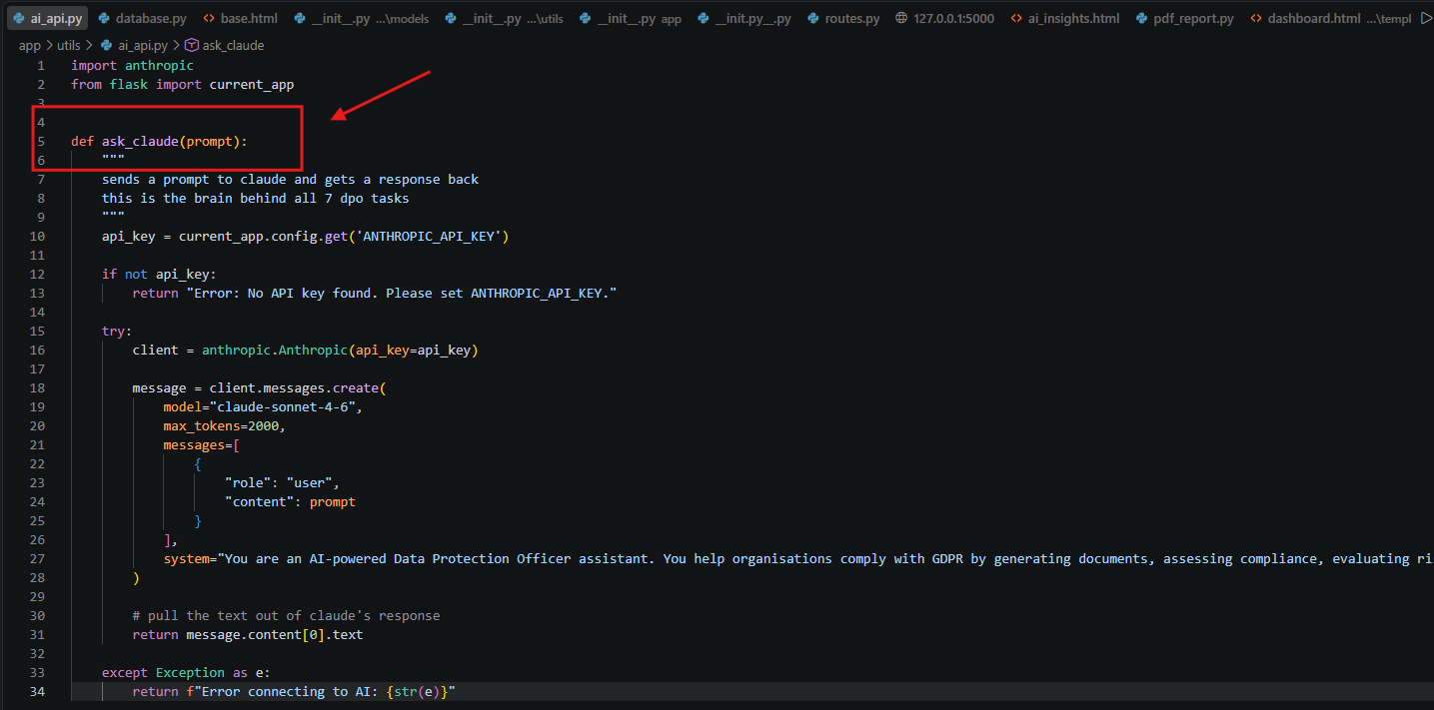
Figure 34: Ai api key integration using ask_claude function

A.2 Detection Engine Patterns

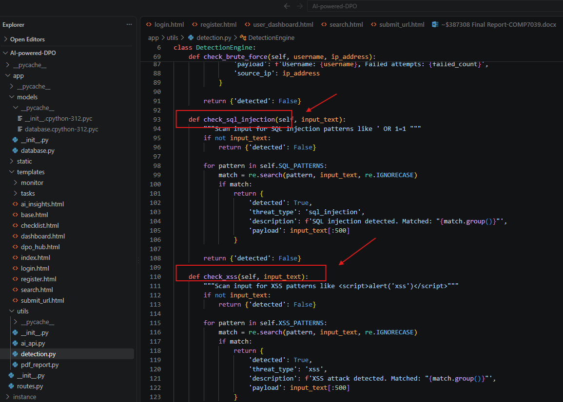

Figure 35: Detection engine pattern function
A.3 Attack Auto classification code

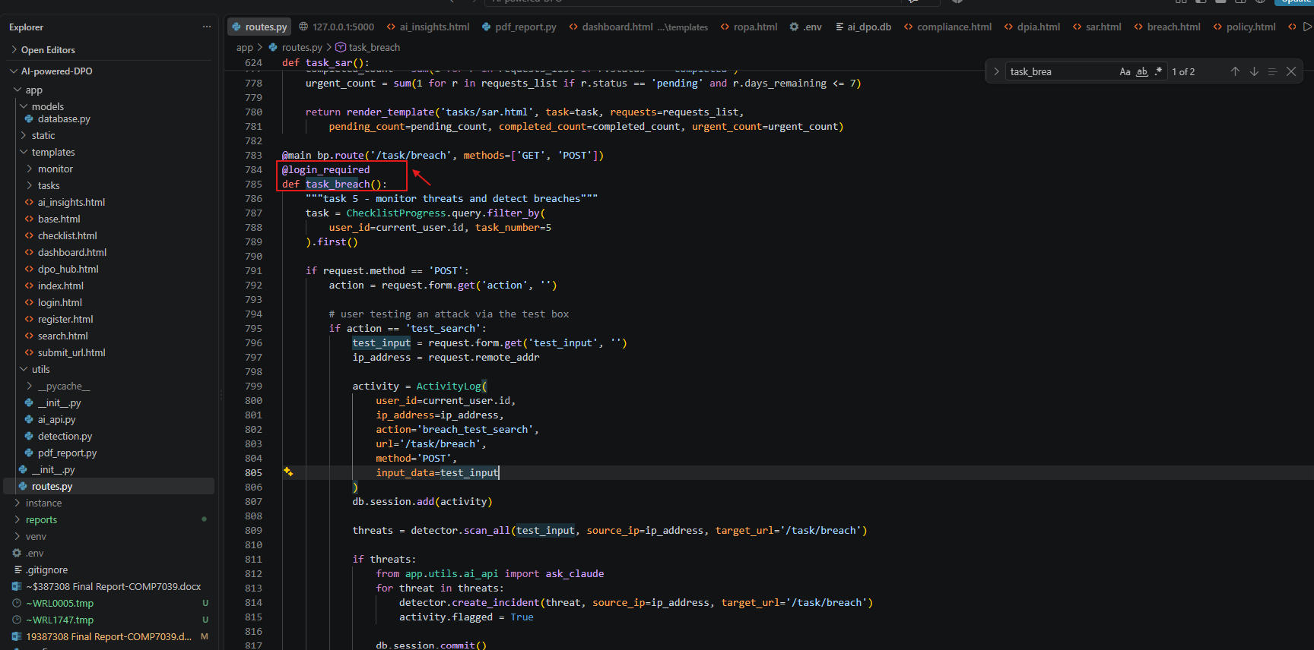
Figure 36: function task breach where incident is created and Ai classifies it

A.4 PDF Report Generation

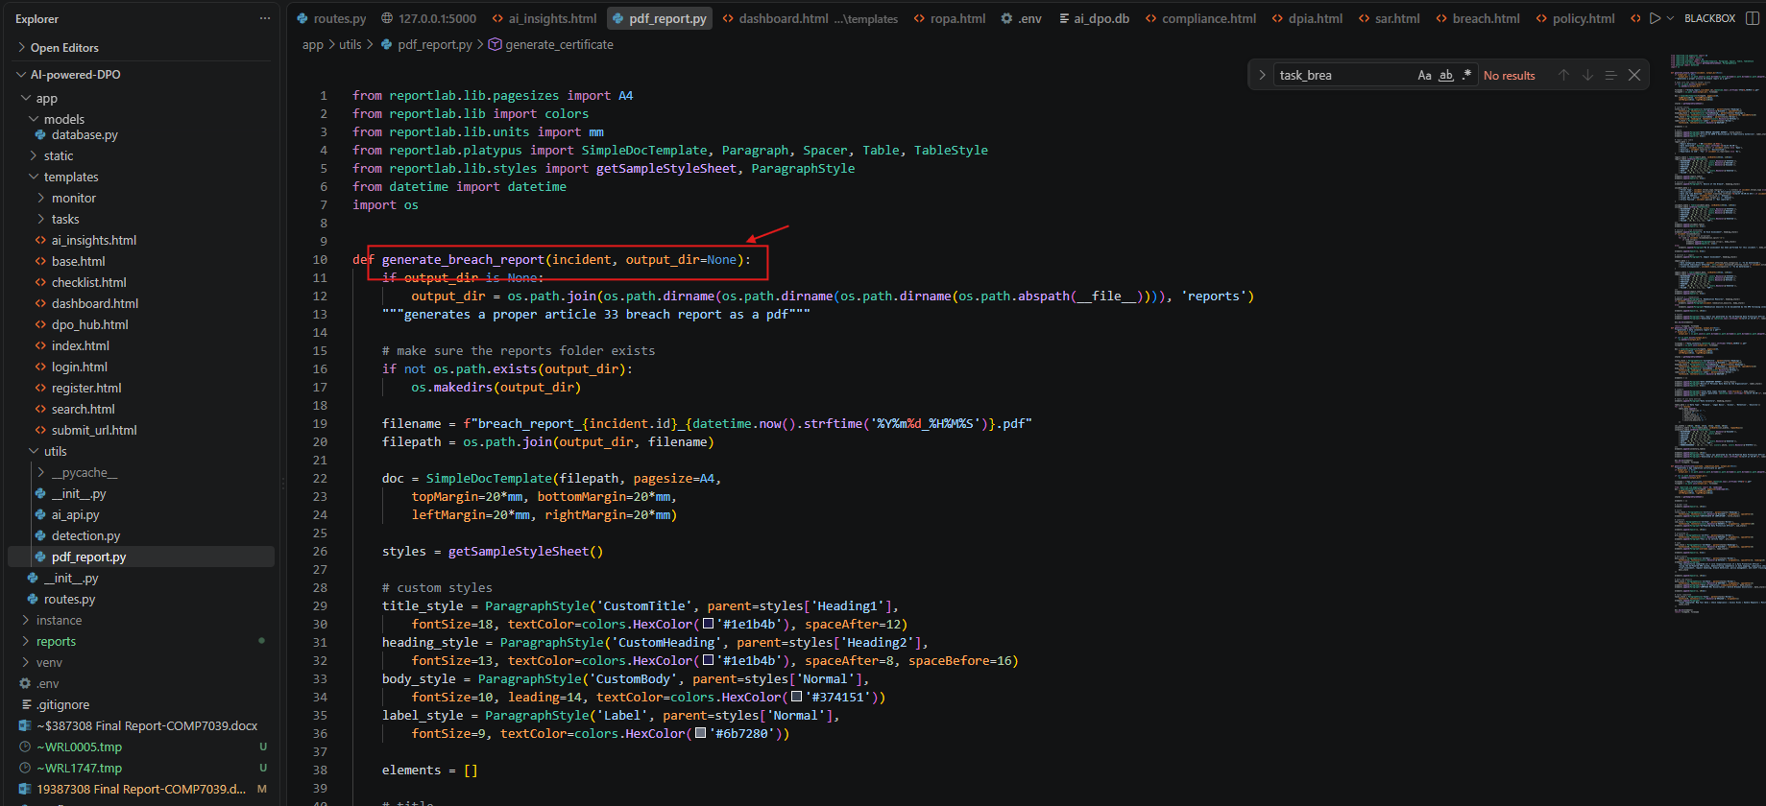

Figure 37: Function to generate pdf breach reports

Appendix B: Links

GitHub Repository
https://github.com/khusigit11/AI-powered-DPO

Google Drive
https://drive.google.com/drive/u/0/folders/1StyOQvFzm61KyavaCaZCwca_0-7kIQgp

Appendix C: Ethics Form:
